QUALIFICATION TEST PROCEDURE

FOR THE

MULTI-OIL LEVEL INDICATOR
AUTOMATION OF THE OLS TEST BENCH

ALLEN AIRCRAFT PRODUCTS, INC.

REPORT #250129
Note:
Yellow Need a file path or other attention
Blue Needs further clarification
Magenta Not Requirement not in original Spec.

PREPARED BY: Rick Ales, Consultant, R. Ales Consulting LLC
Name, Title

APPROVED BY:
Name, Title

ALLEN AIRCRAFT PRODUCTS, INC.

RAVENNA, OHIO
Revision History
Rev | Notes | By | Date
Draft 1 | Initial Draft | R. Ales | 2025/03/18
Draft 4 | Update to reflect Pre & Post-Pot test requirement changes | R. Ales | 2026/06/12
Draft 5 | Rearranged the order of the test cases to more align with logical operation of the MLIO | R. Ales | 2026/07/08
Draft 6 | Clean proofread and aligned requirements with QTP. Added review comments made by Engineering. | R. Ales | 2026/09/23

Table Of Contents
1.0 Purpose of Test Procedure 5
1.1 Reference Documents: 5
1.2 Notation 5
2.0 Test Plan 6
2.1 Requirements Cross Reference Summaries 6
2.2 Test 6
2.3 Analysis 6
2.4 Inspection 6
2.5 Test Results Record 6
3.0 Description of Test Item 6
3.1 General Test Data Requirements 7
3.2 Criteria for Retest 7
4.0 Test Approach 7
4.1 Test Conditions 7
4.2 Measurement Tolerances 8
4.3 Test Fluids 8
4.4 Test Setups/Equipment 8
4.5 Test Procedure Revisions 8
4.6 Allen Aircraft Contacts: 8
5.0 QTP Testing 9
5.1 Functional Requirements Test Procedures 9
5.1.1 Test Initialization 9
5.1.2 Instrument Inputs: 13
5.1.3 Hardware Outputs: 16
5.1.4 Production HMI: 19
5.1.5 Development HMI: 37
5.1.6 Document management 42
5.1.7 Generate DUT Test Report 45
5.1.8 Troubleshooting Aids 51
5.2 Non - Functional Requirements Test Procedures 56
5.2.1 Annual Level Calibration Type 1 Gage and Capability Study 56
5.2.2 Daily Level Zero Correction Check 57
5.2.3 Resistance Calibration Repeatability & Accuracy 58
5.2.4 Measurement Gage R & R 59
5.2.5 Stability and Drift 60
Appendix I. Hardware Installation 61
Appendix II. Instrument Initialization 61
Appendix III. LabVIEW Application Installation 64

- Purpose of Test Procedure
The purpose of the Qualification Testing Procedure is to demonstrate how the Allen Aircraft Automated Oil Level Sensor Test Bench, aka Multi-Level Oil Indicator (MLOI) shall perform within the requirements of Technical Requirements for the Multi-Level Oil Indicator Automated OLS Test Bench, Report #250129 (ReqSpec).
  - Reference Documents:
ACCEPTANCE TEST PROCEDURE FOR ALLEN 8005571.05, Report# 200333
  - Notation
- Means Informative
- Means Test Case traceable to a Requirement
LV LabVIEW
VI Virtual Instrument, a top-level LabVIEW app or a sub processing block
AAP Allen Aircraft Products
QUAM AAP AS9100 Quality Manual
ATP Acceptance Test Procedure
OLS Oil Level Sensor
CIP Custom Interface PCB
DUT Device Under Test
AI Analog Input
XL MS Excel
MLOI Multi-Level Oil Indicator, designation of the automated tester described herein.
Epic 1 Single DUT automated test capability
Epic 2 MLOI capability extended to accommodate other OLS product lines.
Epic 3+ Uses the Custom Interface PCB (CIP). Also, the MLOI capability may be extended to accommodate multiple DUT sensors tested simultaneously (TBD)
HW 1 Prototype phase where all items are COTS and custom configurations are achieved through breadboards or otherwise temporary connections.
HW 2 Production where custom interfaces have been designed and fit-for-purpose interfaces implemented, i.e., an interface unit manufactured as a custom PCB.
<parm> Indicates that the tester should supply the indicated parameter as appropriate.
- Test Plan
  - Requirements Cross Reference Summaries
Test cases and procedures are traceable to the requirements of the ReqSpec by being numbered with the corresponding requirement number.
Upon successful execution of this QTP, the MLOI Automated OLS Test shall be deemed suitable for ATP and production testing of the approved corresponding OLS product. The initial test shall cover EPIC 1 as defined in the ReqSpec for Elevate OLS sensor (PN 8005571.05).
  - Test
Verification that a requirement is met is accomplished by thoroughly exercising the item. This includes actual measurement of unit performance with calculations/analysis as required under controlled and/or recorded environment and in accordance with approved test procedures.
  - Analysis
The requirement is substantiated by Analysis. Analysis is the processing of accumulated results and conclusions to determine whether a requirement has been verified. The analytical results may be based on original study, or derived from lower-level examination, test, demonstration, or a formal analysis.
  - Inspection
Inspection is a visual examination, physical manipulation, weighing and/or measurements to verify that the hardware item conforms to the design requirements and includes review of documentation controlling configuration and requirements.

  - Test Results Record

The test cases shall provide space to record the results of that test case and an overall PASS/FAIL score shall be recorded. This will serve as the Test Results Record when completed and signed off by the designated stakeholders.

- Description of Test Item
The Allen MLOI Automated OLS Test Bench is illustrated in Appendix II. The MLOI is a LabVIEW automated system intended to be a hands-free product test bench that minimizes human product evaluation by controlling the pump and data acquisition system used to precisely control the test tank oil level to a specified Test Point and measure and record the OLS response then determine if the Device Under Test response complies with the designated product ATP specification and report a PASS/FAIL status for that product at the completion of the test.
  - General Test Data Requirements
One MLOI Automated OLS test bench designed to comply with EPIC 1 of the ReqSpec shall be evaluated. One or more designated and characterized OLS products will be used as DUTs to evaluate the performance of the MLOI under test.
Data for each test shall be recorded on individual data sheets. Each sheet shall contain as a minimum the following:
- Test Title: “QTP Results for MLOI Automated OLS Test Bench, EPIC 1”
- Date of test
- Test procedure paragraph reference
- All pertinent environmental conditions
- Type of fluid used and temperature (if applicable)
- Name and signature of test operator(s)
- Equipment, instruments, tolerances, and calibration
- Input, output, and computed data
In addition, photographs of the test unit before and after testing, and of the test setup prior to testing must be taken and provided in the Test Report. Photographs shall be available for customer review prior to testing, if required.
Supporting data, such as a test log, a narrative history of the test and a data acquisition recording of the required test parameters (input and output), if applicable, per the test procedure, shall be made available for customer review.
  - Criteria for Retest
In the event of a test failure, the test shall be suspended and the cognizant <customer> representative shall be notified within 24 hours of the finding. The nature and amount of any redesign and retest shall be coordinated with and approved by <customer> prior to resumption of the test program.
- Test Approach
Unless otherwise specified, the following general requirements shall apply to all Section 5 procedures.
  - Test Conditions
Unless otherwise specified, the tests shall be conducted at ambient temperatures between +70°F and +80°F and at local laboratory ambient pressure and humidity conditions up to 90% relative humidity. The ambient conditions at time of testing shall be provided on the test data sheet, as noted in Section 3.1.
  - Measurement Tolerances
The maximum allowable tolerance on test condition measurements shall be as follows:
- Pressure: ± 2%
- Temperature: ± 2°F
- Flow: ± 2%
Other tolerances shall be as specified in the detailed procedure..
  - Test Fluids
The MLOI test tank will use turbined engine oil conforming to MIL-PRF-2369 or MIL-PRF-7808. The fluids for each test shall be recorded on all data sheets.
  - Test Setups/Equipment
Test setups are defined under the applicable sub-paragraphs of Section 5.1 herein. The Qualification Test Report shall include a complete equipment list identifying each specific instrument used for each test along with its corresponding range and accuracy.
Note: The setups illustrated are a guide. Equivalent instrument substitutes may be used as long as the measurement accuracy of the test parameter is not compromised.
  - Test Procedure Revisions
All test procedure revisions required during test – other than typographical errors that do not change the technical intent of the test - shall be approved in writing by the responsible AR at a minimum and included in the test report. These revisions include, but are not limited to, revisions where the initial stated objective of the procedure or method is not altered, and the means of achieving those stated goals are not altered.
  - Allen Aircraft Contacts:
The following list of Allen Aircraft personnel, unless otherwise noted, are responsible for the Design Testing and Quality verification of the product under test:
George Bush, Chief Engineer, gerogeb@allenaircraft.com
Rober Kline, Product Support Specialist, robertk@allenaircraft.com
Kenneth Duncan, Quality Director, kennethd@allenaircraft.com

- QTP Testing
Functional testing is based on an analysis of ReqSpec. Each Requirement of the ReqSpec shall be tested on a PASS/FAIL basis by the procedures described by test cases of Section 5.1, numbered corresponding to the functional Requirement being tested.
Performance testing includes but is not limited to activities such as Calibration and Gage R&R, which will be described in Section 5.2 and may deviate from the functional requirement numbering system.
  - Functional Requirements Test Procedures
The following test cases describe the test procedures to be used to verify the functional requirement and the success (PASS/FAIL) criteria. The tester should mark the check box if they concur; the test case passed if all check boxes are marked then the test should circle PASS otherwise circle FAIL.

Perform the following steps to load the LabVIEW application (LV), which applies to nearly all the test cases, to conduct the test procedures that follow.

Test Initialization
- As required, have AAP IT department install LabVIEW (LV) Runtime and the current version of the LV MLOI application as shown in Appendix III.
- If testing the development environment, as required, have AAP IT department install LabVIEW Professional Development System on the Target Test System.
NOTE: At this point, MLOI app functionality can be exercised in simulated mode without hardware or instruments installed. If so, skip to Test Case 1).
- Configure the system hardware as shown in Appendix I.
- Initialize the instruments and motor controller as shown in Appendix II

- Verify both the LV application code and HW are version controlled.
- Login to your favorite internet browser and navigate to https://github.com/AllenAircraft/PWC-OLS/tree/main. Contact AAP IT department for login information.
- On the code page, verify that the code under “Main” branch is populated and Release Notes are updatedd.
- Under “Releases” to the right of the code block, verify the “Latest” release revision number corresponds to engineering documentation.
- Verify the hardware drawings, including block diagram, schematic, assembly drawing and Gerber files are released.
- Requirements Specification AR#250129 at <Path file>
- Design Specification AR#260826 at <Path file>
- Quality Test Plan AR#250129 at <Path file>
- Gerber Files at <Path file>
- Schematic and Assembly CAD Files at <Path file>
- Configuration file CFG_8005571-05 Elevate OLS.xlms at <Path file>
- Configuration file CFG_8005571-05 Elevate OLS.csv (used by LV) at <Path file>
- Report Template File RPT_Template_071.xlsx (used by LV) at <Path file>
- The designated Report Record Repository folder is created at <Path file>

Tester __________________ Date ______________ PASS FAIL

- The system shall have distinct modes, Production and Developer.
37) LV program must launch from PC desktop ICON in application running mode.

Operation | Production | Development
- Environment | Run-Time | Developer
- Mode | User | Maintenance or User
- Method | Test | Simulate or Test

- MLOI can operate in one of two environments:
  - Run-time – using the LabVIEW Runtime Engine intended for use by the test operator (tester) to execute the MLOI LabVIEW Application during production.
  - Developer – using LabVIEW Professional Development System where debugging is available and is intended for use by Programmer or Test Engineer for maintenance of the MLOI Program. In Developer environment, the user can select between User Mode and Maintenance Mode.
- MLOI has two Modes:
  - User Mode – displays limited set of front panel controls, available for selection by the production test operator, optional in the developer environment.
  - Maintenance Mode – displays full set of front panel controls available for operator selection in the Developer environment but not available in Runtime environment.
- MLOI has two Methods of operation:
  - Test –Product test using actual OLS Resistor data sourced from the DataQ and Level data sourced from the Laser, using the full functionality and performance of the complete system.
  - Simulate – Uses simulated DataQ, Laser and Motor Control data based on the ATP test table to evaluate the LabVIEW functional portion of the MLOI Test System. Simulate only tests the accuracy of the LabVIEW Software. Simulate is available only in the Developer environment and in the Runtime environment by password-enabled configuration.

- To Test the LabVIEW MLOI application in User Mode in the Production environment, run ..builds\MLOI_Elevate\MLOI_Elevate.exe.
- If testing in the Simulate mode, then proceed to section 5.1.4 Production HMI.
- To Test both the User and Maintenance Mode in the Development environment, navigate to ..\PWC-OLS\ and double-click on _MLOI_Main.vi,
- Verify the Mode dropdown with choice of User and Maintenance is available. (Note other options may be present.)
- Select Maintenance from the Mode dropdown and run the application.
- Verify the Motor controller panel containing Jog button is available.
- If testing using only the Simulate method, proceed to section 5.1.4 Development HMI

- The EPIC 1 System MAY be placed into production service with the HW1 (breadboard) hardware.
- Inspect the Interface Cabinet, check for loose wires, all components are reasonably secure, and strain reliefs are present on all wires that are regularly handled.
Interface Type (circle one) Prototype PCB

- The Interface board is properly installed.
- Cabinet is secure and properly installed.
- The 1KΩ and 100Ω Calibration Reference resistors are available
- The 2.00” Gage block is available
- Cable connector with color-coded clip leads is available
- Precision DC power supply set to 24Vdc @ > 0.200A

Tester __________________ Date ______________ PASS FAIL

- Hardware status shall be indicated as Green = Good to test; Red = Bad or Fault; Yellow = Needs attention or not automatic, i.e. in simulation mode.
17) Shall display instrument status.
- Power on the instrument power and the motor power supplies. Verify the DataQ, Motor controller and Laser USB port are connected to the USB Hub and the USB Hub is connected to the Workstation USB port. See the hardware configuration procedure in Appendix II.
- On the workstation task bar, right-click the start icon and select Device Manager. Verify that each of the units is recognized by the Device Manager. If not, see the installation procedure in Appendix II.
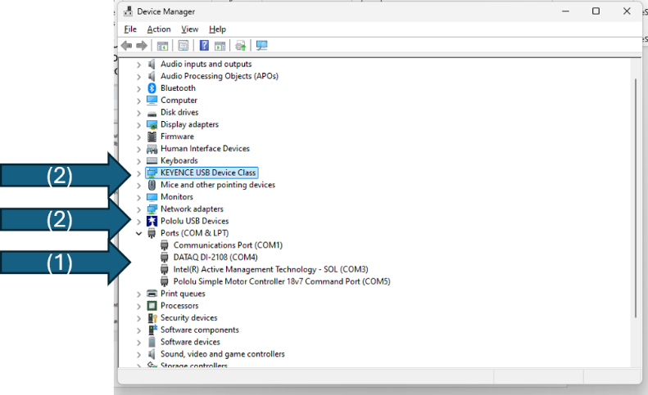
Instruments shown in Device Manager

- Verify that the three devices (1) DataQ, (2) Pololu, (3) Keyence are shown in the Device Manager as shown above.
- Open the MLOI app, click OK.
- Verify the instrument status light is GREEN.
- Disconnect the USB hub from the PC Workstation (see picture).
- Verify the Instrument Status light is YELLOW.
- Verify MLOI starts in Simulated method.
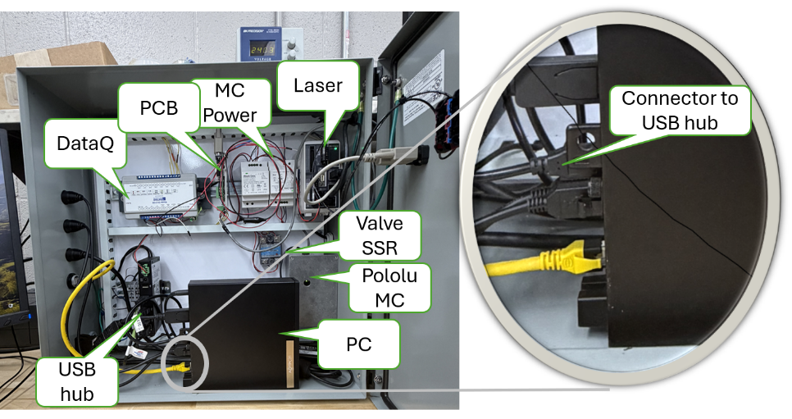
Cabinet contents and PC to USB Hub cable

- Turn OFF the simulated mode by pressing the SIM button
- Must be run in Development environment, select Maintenance Mode.
- Verify Instrument Status light is RED.

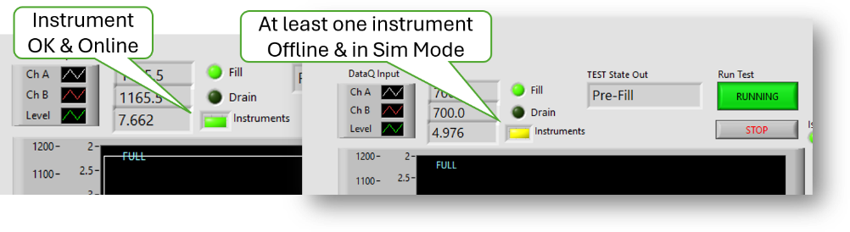
Instruments Status LED and USB Connection to unplug.

- Reconnect the USB hub at the Workstation.
- Verify Instrument Status light is GREEN.

Tester __________________ Date ______________ PASS FAIL

Instrument Inputs:
- ChA and ChB resistance measurement 0-1700Ω +/- 1%
Equipment required:
100Ω and 1KΩ 0.05% Reference Resistors.
Calibrated VOM
System in calibration

- Using the VOM, measure and record the reference value
- Record 100Ω reference resistor ohms in Results Table below.
- Record 1kΩ reference resistor ohms in Results Table below.
- Open the MLOI app, click OK
- Connect the 100Ω resistor to the front panel
- Record Ch A 100 Ω reference reading in Results Table below.
- Record Ch B 100Ω reference reading in Results Table below.
- Connect the 1kΩ resistor to the front panel
- Record Ch A 1kΩ reference reading in Results Table below.
- Record Ch B 1kΩ reference reading in Results Table below.

- Calculate and record the error for the 100Ω and 1kΩ resistors as:

$$Error = {\left.\left( \frac{Ref-Reading}{Ref}\right.\right) x 100}^{}$$

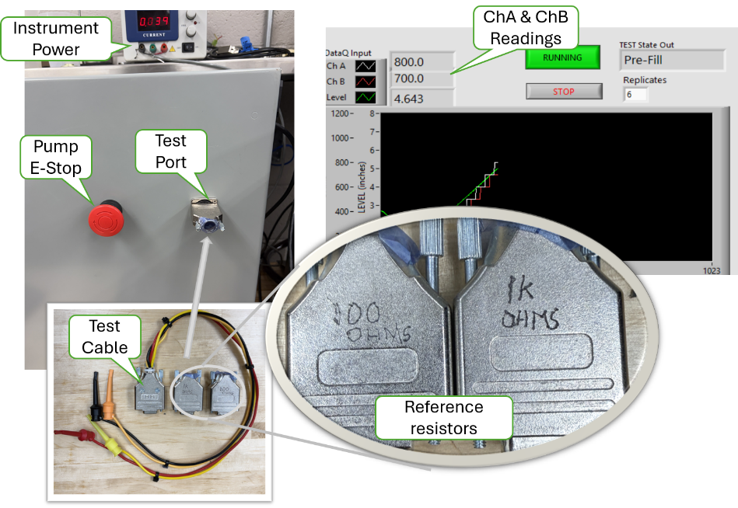
Reference Resistors and Measurement Readout.

Results
Ch | 100Ω | 100Ω Error | 1kΩ | 1kΩ Error
REF
CHA
CHB

- Record the error for each reading in the Results table.
- Both the 100Ω and 1KΩ Error for ChA is less than 1.0%.
- Both the 100Ω and 1KΩ Error for ChB is less than 1.0%.
Tester __________________ Date ______________ PASS FAIL

- ChA and ChB Current Source 14.7 mA +/- 0.05%
Equipment required:
Ammeter
100 Ω and 1 kΩ resistor loads
- Set the Ammeter to the 100mA range and ensure that the probes are set to read current.
- Connect the AM + (pos) lead to the ChA Orange lead and connect the AM – (neg) lead to the ChA Black lead.
- Record the current reading. ___________________ mA
- The current reading for ChA was between 14.693 and 14.707 mA
- Connect the AM + (pos) lead to the ChB Red lead and connect the AM – (neg) lead to ChB Yellow lead.
- Record the current reading. ___________________ mA
- The current reading for ChB was between 14.693 and 14.707 mA

Tester __________________ Date ______________ PASS FAIL

- Level measurement (Process Variable PV) 2.5 to 8.5 inches +/- 0.005”
- Run the Level Accuracy and Repeatability evaluation defined in Section 5.2.1.
- Level accuracy was successfully demonstrated during the Accuracy and Repeatability evaluation of Section 5.2.1.

Tester __________________ Date ______________ PASS FAIL

Hardware Outputs:
- Level control (Set Point SP) 2.5 to 8.5 inches +/- 0.005”
- Run the MLOI app.
- Select Pre-Pot, turn OFF Pre-Fill then click OK
- Verify the Level Controller is displayed
- Wait for Pump Speed to indicate STOP.

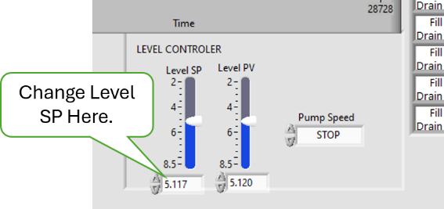
Level Controller
- Check Level Accuracy measured in Level PV vs Level SP
- Change the set point, Level SP to a Test Level between 2.5 and 8.5
- Verify the Pump Speed indicates speeds of FAST, SLOW, CREEP and IDLE. NOTE: the Pump Speed may hunt between CREEP and IDLE for several cycles.
- Verify eventually the Pump Speed indicates STOP and the motor is stopped (i.e., quiet).
- Verify the difference between Level SP and Level PV is less than 0.005”
- Repeat Step 2 for the following values
- Level SP = 3.00
- Level SP = 5.26
- Level SP = 7.50

Tester __________________ Date ______________ PASS FAIL

- Pump back flow shall be prevented.
- Open the Cabinet then Run the MLOI app.
- Select Pre-Pot, turn OFF Pre-Fill then click OK
- Verify the Level Controller is displayed
- Wait for Pump Speed to indicate STOP.
- Check the operation of the back flow preventer valve
- Verify the Valve SSR (Solid State Relay) red light is ON.
- Change Level SP, note a clunk sound.
- Verify the Valve SSR red light is OFF while Pump Speed is NOT STOP
- Verify the Valve SSR red light is ON when Pump Speed is STOP.
- Repeat Step 2 for several Level SP values
- Verify correct operation of Valve SSR.

Tester __________________ Date ______________ PASS FAIL

- A Pump E-Stop shall be provided.
NOTE: The Pololu smart motor controller detects various faults including low voltage IN must be on line for this test. Once a Fault is cleared, the Pololu must be reset, this test is deemed to satisfactorily evaluate the Pololu fault feature.
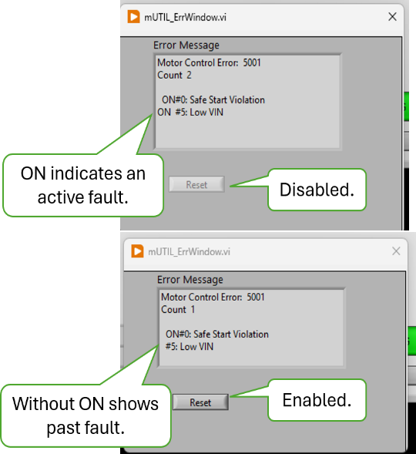
- Run the MLOI app. Click OK
- Remove Pump voltage IN.
- Press the Red button on the Cabinet to remove voltage IN.
- Change Level SP verify the pump will not engage
- Verify the Motor Control Error message with the Reset button disabled.
- Restore Pump voltage,
- Turn the Red button on the Cabinet clockwise to restore voltage IN.
- Change Level SP verify the pump will not engage
- Verify the Motor Control Error message with the Reset button Enabled.
- Press Reset button.
- Verify the pop-up is dismissed.
- Change Level SP, verify the pump engages and Level PV is changing.

Tester __________________ Date ______________ PASS FAIL

Production HMI:

NOTE: These HMI tests of software requirements may be evaluated in either test (with instrumentation) or simulated (without instrumentation) methods. The following tests may be evaluated in SIM mode except as noted.

NOTE: The Main Indicators and controls are shown below. Each control and indicator has a tool tip available with right-click.

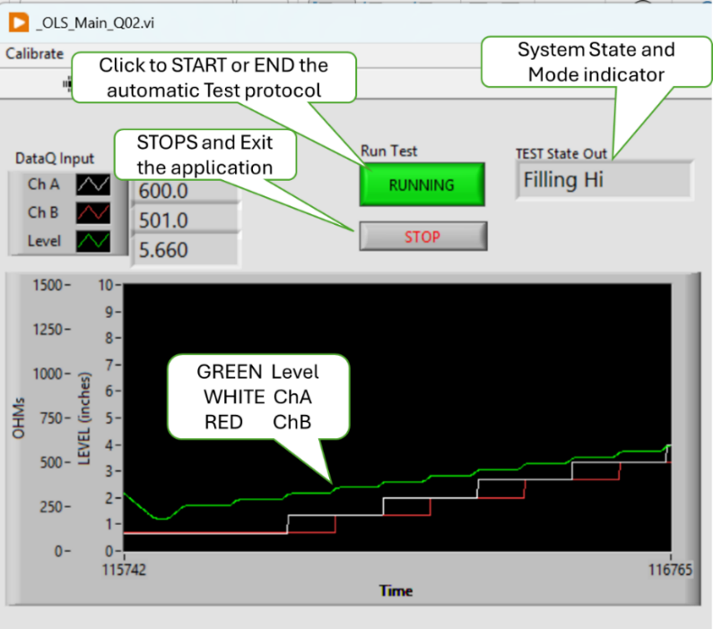
- Shall provide a means to check and set the Level Zero point daily.
- Verify the Zero Prompt occurs after Test Info Dialog is dismissed.
- Note the value of Level_Zero_Gage value in the $ConfigFile. (-2.000 default)
- If Zero Prompt is not displayed on starting MLOI Program, then in windows start, type Regedit. Navigate to Computer\HKEY_CURRENT_USER\Allen AirCraft\MLOI-Elevate and select Level Zero Date, Click Edit>Modify set Value Data to a date prior to today(). Click OK
- Start the MLOI Program. At the test info dialog, click OK, the Zero Dialog should appear saying looking for laser. The laser is found, go to Step 2
- At Error message 534288 click OK. On Laser Not Found, Click on TEST.
- Go to Step 3

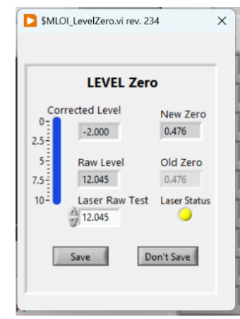
- If in Simulate Method
- Verify that the Laser Status is yellow.
- Verify changing Laser Raw Test input is reflected in Raw Level and New Zero values.
- Note the New Zero value and Click Save
- Restart by clicking on Calibrate>Level Zero and verify the Old Zero value is the New Zero value noted above.

- If in Test Method (Laser is on-line)
- Verify that the Laser Status is Green.
- Verify Laser Raw Test input is hidden.
- Insert a laser target, then note the New Zero value and Click Save see paragraph 5.2.2 Daily Level Zero Correction Check
- Restart by clicking on Calibrate>Level Zero and verify the Old Zero value is the New Zero value noted above.
- Remove the laser target.

- Verify test when Laser is Found.
- Verify the user is prompted to place the gage block on the datum reference plane.
- With the gage block as shown, Note the New Zero then Click on Save.
- Press STOP to end the MLOI Program.

- Verify that the Level Zero is persistent.
- Start MLOI, verify that the Level Zero prompt is NOT displayed after the Test Info is dismissed.
- Press STOP to end the MLOI Program.
- Reset Level Zero Date in the registry, restart MLOI and verify that the Zero value noted above is now displayed in Old Zero.

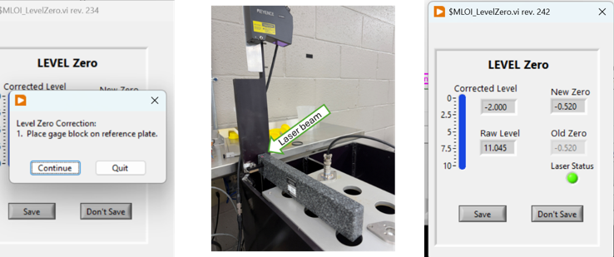

Tester __________________ Date ______________ PASS FAIL

- Level measurement zero calibration check shall be enforced daily
- In the Win11 search bar type “RegEdit” and start the Registry Editor.
- In the folder tree in the left pane navigate to:
- Computer\HKEY_CURRENT_USER\Allen AirCraft\Elevate OLS Test
- Open the Elevate OLS Test Key folder, then click on Level Cal Date,
- On the menu click Edit>Modify.
- In the Edit popup enter the test date.

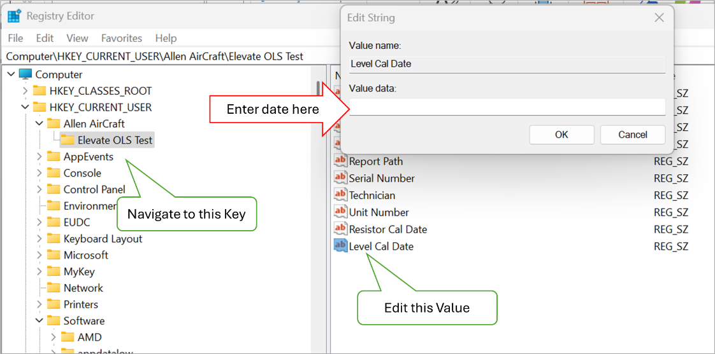
- With the Registry’s Level Cal Date Set to Today.
- Perform Step 2 with entering today’s date.
- Editor Start the MLOI application, Click OK
- Verify there was no prompt to perform a Level calibration.
- Stop the MLOI application
- With the Registry’s Level Cal Date Set to any date but today’s date.
- Perform Step 2 with entering today's date.
- Editor Start the MLOI application, Click OK
- Verify the user was prompted to perform a resistor calibration.
- Repeat Step 4 for four other random dates.

Tester __________________ Date ______________ PASS FAIL

- Shall provide a means to check correct application version is used with the selected Configuration File.
24) The test plan shall contain the configurable test bench parameters as determined by the test bench design.
25) Tabular data should be copied and pasted from the reference Test Document (ATP) into the XL Test Plan document for loading as an LV parameter.
26) The test plan shall contain the referenced test protocol test bench parameters as determined by the test bench design.
27) The test bench parameters should be copied and pasted into the XL Test Plan document.
28) The Test Plan shall contain a template of each test report generated on a separate sheet in the test plan XL workbook.
32) These Bench calibrations shall be saved and linked to the Test Plan.
38) Maintenance User exclusive controls and Indicators shall be hidden in Test mode

- Start builds ..\builds\MLOI_Elevate\MLOI_Elevate.exe, click OK.
- On the menu select View>Files & Paths.
- Note the ConfigFile.xlsx file name then open the configured $ConfigFile.
- Edit LabVIEW Version (Cell B50) to be some version number i.e., 0.11.22.33
- If necessary, unblock the file as follows:
- Close the Office file.
- In File Explorer, right-click the file.
- Select Properties.
- On the General tab, look for Security.
- Check Unblock.
- Save the ConfigFile.xlsx by clicking on the X then Yes, Yes to write the ConfigFile.csv which is what the program uses.
- Close MLOI by clicking STOP.
- Check that Version mismatch warning is displayed.
- Start MLOI_Elevate click OK
- Verify that Version mismatch warning is displayed with Expected Version is the value entered above i.e., 00.11.22.33 and Found Version is the Version of the MLOI app,
- Click Stop, Verify the app closes.
- Start MLOI_Elevate click OK
- Verify that Version mismatch warning is displayed with Expected Version is the value entered above i.e., 00.11.22.33 and Found Version is the Version of the MLOI app.
- Note the Found Version number returned.
- Click Continue, verify that program continues
- Check that Version mismatch warning is NOT displayed when the configured version matches the application version number.
- Edit the calibration file, set LabVIEW Version (Cell B50) to be the version number noted above.
- Save the configuration file.
- Start MLOI_Elevate click OK
- Verify that Version mismatch warning is NOT displayed.
- Verify that the configuration file matches the specified ATP and specified parameters.
- The Transition table is the same as the reference ATP document.
- The Calibration Constants are from the specified calibration table.
- The Pump Parameters meet configuration specifications.
- The correct Report Template is referenced

Tester __________________ Date ______________ PASS FAIL

- Shall not require operator to enter redundant information.
39) All Test Parameter options must be presented as discrete choices (e.g., d 40) 40) Path to valid XL test plans shall be saved in a non-volatile means and presented as a choice by Test name configured by the Maintenance User. ropdown menus, pick lists, or radio buttons).
42) Engineering shall provide an ATP Test report template that provides the reference for the required DUT Test Information.
43) There shall be a single dialog box to enter the required DUT test information.
44) The DUT information input shall be displayed for confirmation in an “Are you sure?” prompt with YES and NO choices. On a NO response, the user must be able to update the retained, editable input.
47) The Test protocol shall implement the ACCEPTANCE TEST PROCEDURE FOR ALLEN 8005571.05, Report# 200333. (attached)

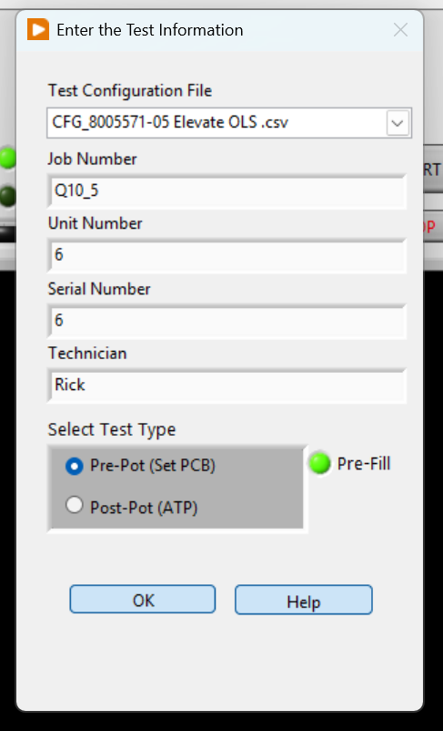
For this section, refer to the figure on the right:
- Click on the MLOI Desktop icon and run the application.
- Verify the application open, in MANUAL mode and Test Information dialog is open.
- Verify all program options are selected from discrete choice or from a list.

- Evaluate Test Configuration File dropdown.
- Click the dropdown, then verify a choice of at least one product test configuration file is presented.
- Click on each of the file name, then verify each is selected indicated by a check mark and presented in the test box when the dropdown is closed.
- Click OK then EXIT to quit the MLOI Program, restart the program and verify that the selected test configuration file entered above persists in the Configuration File dropdown.
- Repeat Step 2 for each available configuration file.

- Evaluate Test Information.
- Start the MLOI Program, On the Test Information dialog, enter some random test in each of the Job Number, Unit Number, Serial Number, Technician and Notes Fields. Click OK
- Click CANCEL, then STOP to quit the MLOI Program
- Restart the MLOI Program and Verify that information entered above persists.

- Evaluate Pre-Fill Lube disable.
- With the “Pre-Fill” light illuminated GREEN, Click OK
- Verify the Program starts and “Pre-Fill is indicated in the TEST State Out box.
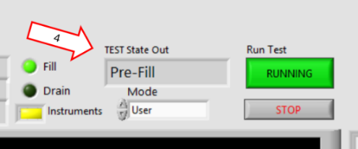
- Stop and restart MLOI.
- Click on the “Pre-Fill” light to turn it OFF (dark), Click OK
- Verify the Program starts, the pre-lube operation is skipped, and “Filling” is indicated in the TEST State Out box.

- Evaluate Help
- Click on the Help button, verify that the instruction PDF launches.
- Evaluate Test Options
- Start the MLOI Program,
- In the Select Test Type box, Select the Pre-Pot radio button. Press OK
- Verify the system starts in manual mode and the Level Controller is displayed.
- Verify that moving the Set Point indicator (Level SP) causes the system Process Variable (Level PV) to respond in kind for various levels.
- Click the START button, verify that the automatic test runs.
- Press STOP, No Quit to exit MLOI Program after each observation.
- Repeat, verify that the Pre-Pot Test remains selected.
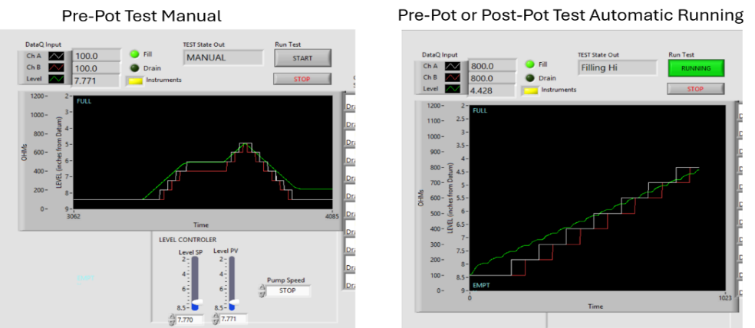
- Start the MLOI Program,
- In the Select Test Type box, Select the Post-Pot radio button. Press OK
- Verify that the program starts in automatic Running.
- Press STOP, No Quit to exit MLOI Program after each observation.
- Repeat, verify that the Post-Pot Test remains selected.

Tester __________________ Date ______________ PASS FAIL
16A) Shall provide help for each control and indicator.
- Evaluate that each control or indicator has a “tool tip” displayed when mousing over the item or right-clicked and “Description & Tip” is selected.
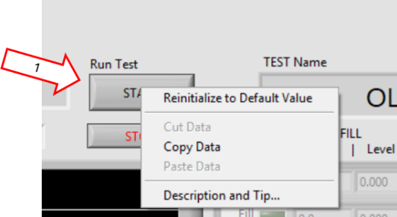
- Right-click on the Run Test button, select “Description & Tip,” verify the appropriate tool tip is displayed.

- Hover the mouse over the Run Test button, verify the short tool tip is displayed.
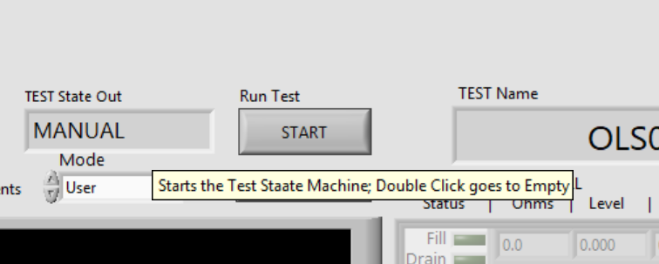

- Repeat for each control and indicator.

Tester __________________ Date ______________ PASS FAIL

- Shall provide a menu means to launch secondary methods.
18A) Shall provide a menu driven means to access features.
23) There shall be a means to add/include the test plan path into the user prompt.

- Open MLOI in the developer environment
- Ensure NI LabVIEW Developer is installed on the test workstation
- If not loaded, use git to clone the main version of the PWC_OLS project from https://github.com/AllenAircraft/PWC-OLS
- Open MLOI by clicking on ../PWC-OLS/_MLOI_Main.vi
- Select the specified Mode, either User or Maintenance.
- Click on the Run Arrow (⇒).
- This will leave you at the Input Test Information dialog. Click OK to continue.
- If in Maintenance MODE
- A hardware not found Error 18v7 is displayed, click SIMULATE to continue.
- A DataQ not found Error -1073807343 is displayed, click Simulate to continue.
- The Level Zero - Looking for Laser is displayed, then Lase not found Error 524288 is displayed, click Continue to Continue.
- On Laser Not Found dialog Click Quit to set the Zero Date to today, so the Zero Dialog is suppressed for the rest of the day.

- If in User MODE
- The Level Zero - Looking for Laser is displayed, then Lase not found Error 524288 is displayed, click Continue to Continue.
- On Laser Not Found dialog Click Quit to set the Zero Date to today, so the Zero Dialog is suppressed for the rest of the day.
- MLOI is now open in the Test Type selected on the Test Information dialog in the Simulate method.

- Evaluate File>Issue Log.
- Open MLOI in Maintenance Mode as described in Step 1
- Click on View>Files & Paths. Note the Path to Issues Log as <Issue Path>.
- Navigate to <Issue Path>\BugLog.txt. Create folder and/or text file named BugLog.txt if it does not exist.
- Click on File>Issue Log
- Enter sample data in the Issue Dialog form. Click OK
- Open file <Issue Path>\BugLog.txt and verify that the sample data entered is correct.
- Delete file <Issue Path>\BugLog.txt
- Click on File>Issue Log, Enter sample data in the Issue Dialog form. Click OK
- Verify that the File dialog opens and creates <Issue Path>\BugLog.txt
- Open file <Issue Path>\BugLog.txt and verify that the sample data entered is correct.
- Repeat the above Step in User Mode.
- Evaluate File>Stop.
- Open MLOI in Maintenance Mode as described in Step 1
- Click File>Stop, verify Stop dialog is displayed.
- Click Continue, verify the Stop dialog is dismissed and MLOI continues.
- Click Quit, verify MLOI stops.
- Repeat the above Step in User Mode.
- Evaluate File>Exit.
- Open MLOI in Maintenance Mode as described in Step 1
- Click File>Exit, verify Exit dialog is displayed.
- Click Save, verify a Test Report is generated, and the Exit dialog is dismissed.
- Click No Quit, verify MLOI stops.
- Repeat the above Step in User Mode.
- Evaluate View>Files & Paths
- Open MLOI in Maintenance Mode as described in Step 1
- Click View>Files & Paths, verify Files & Paths dialog is displayed.
- Verify Config File Path is displayed, then navigate to verify the folder exists.
- Verify Report File Path is displayed, then navigate to verify the folder exists.
- Verify Issue Log File Path is displayed, then navigate to verify the folder exists.
- Repeat the above Step in User Mode.
- Evaluate View>Test Info
- Open MLOI in Maintenance Mode as described in Step 1, however, enter sample data when the Test Information dialog is presented.
- Click View>Test Info, verify Test Info dialog is displayed.
- Verify Job Number, Unit Number, Serial Number and Technician data displayed corresponds to the sample data entered above.
- Click Stop, restart the program
- Click View>Test Info, verify Test Info dialog is displayed.
- Verify the data presented is persistent and the same as the data entered above.
- Repeat the above Step in User Mode.
- Evaluate View>Calibration Params
- Open MLOI in Maintenance Mode as described in Step 1
- Click on View>Files & Paths. Note the Path to Config File as <Config Path>.
- Navigate to <Config Path> and open the Excel Configuration file. Note the values in the table below.
AI1 Slope |  | AI1 Offset |  | AI2  Slope |  | AI2 Slope
Laser Slope |  | Laser Offset |  | Level Cal Date

- Click View>Calibration Params, verify the Calibration Params dialog is displayed.
- Verify AI1 Slope, AI1 Offset, AI2 Slope, AI2 Offset, Laser Slope, Laser Offset and Laser Cal Date data displayed corresponds to the sample data entered above.
- Repeat the above Step in User Mode.
- Evaluate Calibrate>Level Zero
- Open MLOI in Maintenance Mode as described in Step 1
- Click on Calibrate>Level Zero verify the Level Zero dialog is displayed indicating Looking for Laser.
- Wait about 10 seconds for the laser not found error to be displayed then press Continue.
- At the Laser not found message, click on Quit.
- Repeat the above Step in User Mode.
- Evaluate Calibrate>Resistance
- Open MLOI in Maintenance Mode as described in Step 1.
- Click Calibrate>Resistance, verify Resistance Calibration dialog is displayed.
- Functionality of the Resistance calibration is assessed in paragraph 5.2.3 Resistance Calibration Repeatability & Accuracy
- Repeat the above Step in User Mode.
- Evaluate Calibrate>Level
- Open MLOI in Maintenance Mode as described in Step 1.
- Click Calibrate>Level, verify Level Calibration dialog is displayed.
- Functionality of the Level calibration is assessed in paragraph 5.2.1 Annual Level Calibration Type 1 Gage and Capability Study
- Repeat the above Step in User Mode.
- Evaluate Maintenance>Initialize
- Open MLOI in Maintenance Mode as described in Step 1.
- Click Maintenance>Initialize, verify Level Initialize dialog is displayed and requests to input access code.
- Click OK, verify a “Wrong Code, try again” message. Click OK.
- Click on View>Files & Paths. Note the Path to Config File as <Config Path>.
- Navigate to <Config Path> and open the Excel Configuration file, note the Maintenance_Code value.
- Click Maintenance>Initialize and enter the Maintenance_Code noted above.
- Verify the Maintenance dialog is presented.
- The functionality of the Maintenance dialog is evaluated in
- Repeat the above Step in User Mode.
- Evaluate Maintenance>Configuration
- Open MLOI in Maintenance Mode as described in Step 1.
- Click Calibrate>Level, verify Level Calibration dialog is displayed.
- Verify the data from Test Information Data: Job Number, Unit Number, Serial Number, Technician and Notes are displayed
- Verify Files & Paths: the config file and reports files path are displayed.
- Verify Test Parameters: Pre-Fill, Start in JOG, Replicates, Mode, Auto Start are displayed
- Verify the daily zero: Level Zero Correction value and Level Zero Date are displayed
- Repeat the above Step in User Mode.
- Evaluate Maintenance>Reset Motor Control
- Ensure the instrumentation is online. (Not applicable in Simulate method)
- Open MLOI in Maintenance Mode as described in Step 1.
- TEST STEPS
- Repeat the above Step in User Mode.
- Evaluate Maintenance>Test Tank
- Ensure the instrumentation is online. (Not applicable in Simulate method)
- Open MLOI in Maintenance Mode as described in Step 1.
- TEST STEPS
- Repeat the above Step in User Mode.
- Evaluate Help>Instruction
- Open MLOI in Maintenance Mode as described in Step 1.
- Click on Help>Instruction, verify the file ...\$Help\ HELP_Instruction.pdf
- opens in the system browser.
- Rename ...\$Help\ HELP_Instruction.pdf to ...\$Help\ HELP_Instruction.TST
- Click on Help>Instruction, verify the “Place the Instruction file to $Help folder message” is displayed.
- Rename ...\$Help\ HELP_Instruction.TST to ...\$Help\ HELP_Instruction.pdf
- Repeat the above Steps in User Mode.
- Evaluate Help>About menu item. (Production)
- In Production (Run-time) Environment, run ..MLOI_Elevate\MLOI_Elevate.exe, \
- Click OK. On the menu select View>Files & Paths.
- Note the ConfigFile.xlsx file name then open the configured $ConfigFile.
- Navigate to <Config Path>, open the Excel Configuration file, and Note the value in LabVIEW Version (Cell B50).
- If available, navigate to the PWC_OLS project folder, click on MLOI_OLS.lvprj. expand Build Specifications, then click on MLOI_Elevate
- In the left-hand pane, click on Version Information and.
- Else navigate to https://github.com/AllenAircraft/PWC-OLS and Note the Version Number found in the release notes.
- Click on Help>About, verify:
      - Product is MLOI Elevate;
      - Expected Version is the Config File Version noted above;
      - Found Version is the version number found in the build specification or the Github Release Notes.
      - Company is Allen Aircraft Products and
      - Date is 7/28/2026.

- Evaluate Help>About (Development)
- In Development Environment, run ..MLOI_Elevate\MLOI_Elevate.exe, \
- Click OK. On the menu select View>Files & Paths.
- Note the ConfigFile.xlsx file name then open the configured $ConfigFile.
- Navigate to <Config Path>, open the Excel Configuration file, and Note the value in LabVIEW Version (Cell B50).
- Click on Help>About, verify:
      - Product is MLOI Elevate;
      - Expected Version is the Config File Version noted above;
      - Development Mode:
      - Company is Allen Aircraft Products and
      - Date is 7/28/2026.

Tester __________________ Date ______________ PASS FAIL

- Shall provide a one-button means for starting the automated test.

NOTE: There are two Test Types:
- Pre-Pot which starts in MANUAL allowing the user to manually adjust the Level Set Point. Pressing the START button causes the stepped level protocol to Run.
- Post-Pot This is the ATP Test. It can be either automatically or manually started based on Test Information setting. When running, it executes the Stepped Test Protocol driven by the Test State Machine.
- Pre-Fill This is a fast fill and empty of the tank to lubricate the sensor prior to test unless disabled by the user.
NOTE: A Post-Pot Test auto-start option has been added in the Test Information Settings.

NOTE: Test Cases 20 – 23 shall demonstrate the Post-Pot Test for functional evaluation.

- Shall display the current ChA and ChB measurement to 0.1Ω
- Shall display the level measurement to 0.001”
- Shall provide time-based plot of resistance for both ChA and ChB, and tank Level.
48) The oil level shall be cycled from empty to full to empty prior to testing.
49) The oil level shall be filled from empty to the Target Test Point.
50) The Resistance shall be measured after any level variations subside to the specified criteria.
51) If the measured resistance is within the specified tolerance, the test at this level is PASS; otherwise, a FAIL shall be logged.
52) The above three steps are repeated for each Low Fill Limit alternating between measuring ChA and ChB.
53) The oil level shall be drained from full to the Target Test Point.
54) The Resistance shall be measured after any level variations subside to the specified criteria.
55) If the measured resistance is within the specified tolerance, the test at this level is PASS; otherwise, a FAIL shall be logged.
56) The above three steps are repeated for each High Drain Limit, alternating between measuring ChA and ChB.
57) The DUT shall be recorded as PASS if no FAILs are recorded.
58) The test status shall graphically display Ch A & Ch B resistance in ohms and display the Level in inches.
59) All three traces shall be scaled so that they are overlaid at a similar size. The chart scale is a configurable test parameter.
60) A display shall indicate each switch status as NOT TESTED (gray), PASS (green), FAIL (red), or ERROR (yellow) for a detected procedural problem.
61) A display shall indicate the measured Target Test Point and the actual resistance measured there.
62) The User must have the means to monitor the Test bench health during testing.
63) Users must have a means to PAUSE the test.
64) Users must have a means to ABORT the test.
65) Users must have the option to RERUN the test.
66) Users must have the option to run the level in manual or automatic modes.
67) The default test mode is automatic
- Disconnect the Instruments
NOTE: This test may be run with Instruments and an OLS sensor installed but result values and indicator may vary.
- Run MLOI. Start the MLOI Program, On the Test Information dialog, set:
Test | Post-Pot |  | Pre-Fill to | OFF
- Click OK,
- Verify the Instruments LED is Yellow indicating the Simulation Mode.
- On the menu select View>Files & Paths and note the path to the report files folder
- Verify that Current Test State Out is sequencing through the test protocol.

- Allow the Post-Pot test to run for several moments to develop a data plot in the Test Progress Display
- Verify Ch A Ohms, Ch B Ohms show a value with xxx.x format above the chart and change with the charted data.
- Verify Level Inches show a value with x.xxx format above the chart and change with the charted data.
- Verify a green stair-step plot on the chart representing the Level data.
- Verify a white stair-step plot on the chart representing Ch A Ohms
- Verify a red stair-step plot on the chart representing Ch B Ohms
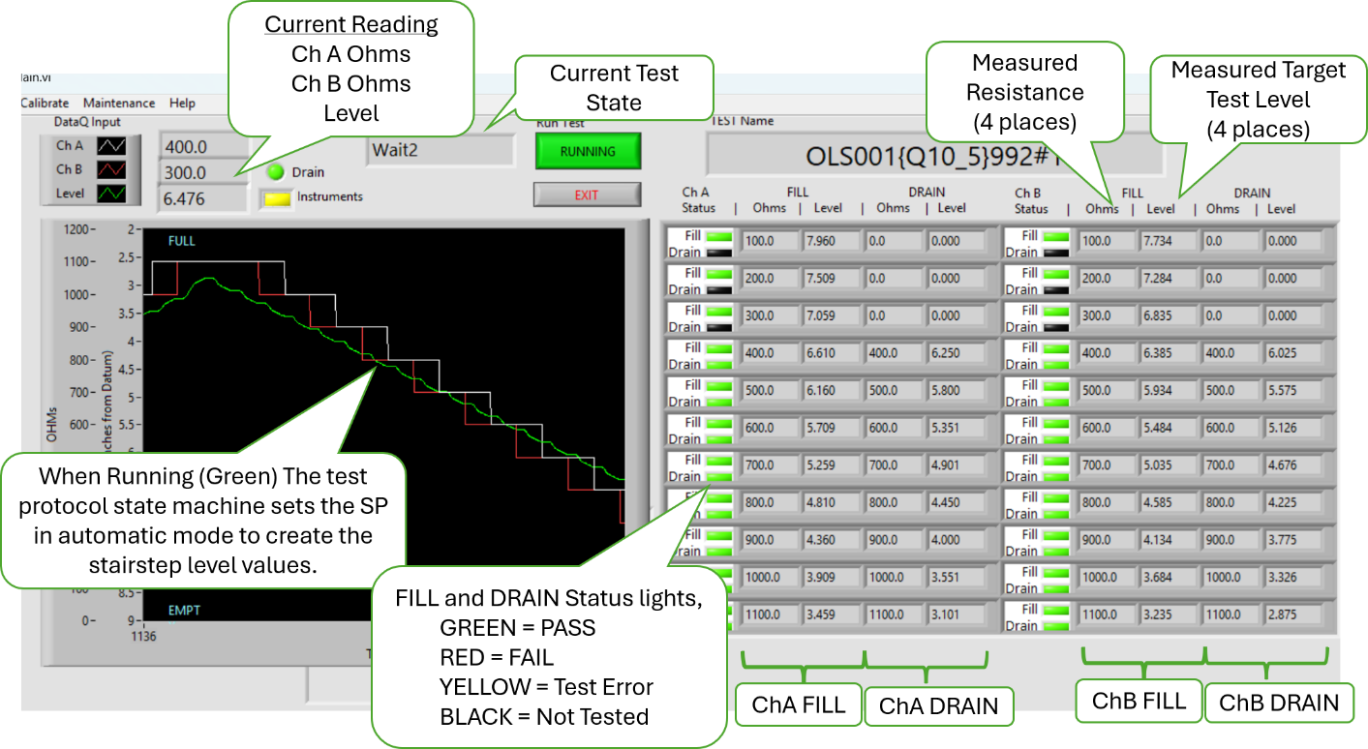
Test Progress Display
- Skip to step 3 of Test Case 22.

- Shall display the Pass/Fail status and progress of the test.
- Disconnect the Instruments
- Run MLOI. Start the MLOI Program, On the Test Information dialog, set:
Test | Post-Pot |  | Pre-Fill to | OFF
- Click OK,
- Verify the Instruments LED is Yellow indicating the Simulation Mode.
- On the menu select View>Files & Paths and note the path to the report files folder
- Verify that Current Test State Out is sequencing through the test protocol.
- Allow the Post-Pot test to run for several moments to develop a Status Table in the Test Progress Display (shown above)
- Verify that Ch A Ohms, Ch B Ohms Measured Resistance and Measured Target Level Values for each step.
- Verify both the Fill and Drain status lights indicate test status as the test progresses.
- Verify the FILL and DRAIN Status lights change from dark to green as the test progresses.
- Wait until the test is completed (DONE state) and the app closes.
- Verify that a report is generated and saved as an XL workbook in the noted report folder.

Tester __________________ Date ______________ PASS FAIL

- Shall provide a means to determine the initial PCB set depth.
- Shall provide a means to determine sensor viability before potting process.
- Pre-Pot which starts in MANUAL allowing the user to manually adjust the Level Set Point. Pressing the START button causes the stepped level protocol to Run.
- Pre-Fill This is a fast fill and empty of the tank to lubricate the sensor prior to test unless disabled by the user.

- Disconnect the Instruments
NOTE: This test may be run with Instruments and an OLS sensor installed but result values and indicator may vary.
- Start the MLOI Program and wait for the Level to STOP.
- On the Test Information dialog, set:
Test | Pre-Pot |  | Pre-Fill to | OFF
- Verify the application is open and running and TEST State Out is in MANUAL mode.
- On the menu select View>Files & Paths and note the path to the report files folder
- Verify the Level Controller is visible.
- Verify the Level drives to Empty (~8.4”) and the Speed is STOP.

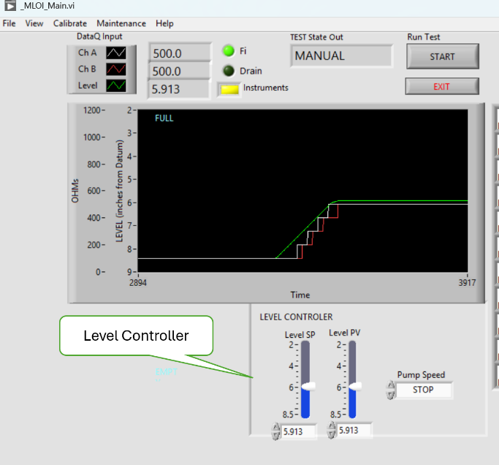
Pre-Pot Test Display

- Change the Level SP (Set Point).
- Verify plot and readings indicate level driving to Level SP
- Verify that Pump Speed STOPs and Level PV (Process Value) is approximately equal to Level SP
- Repeat Step 3 for at least 5 values of Level SP. For each trial:
- Verify plot and readings indicate level driving to Level SP
- Verify that Pump Speed STOPs and Level PV (Process Value) is approximately equal to Level SP
NOTE: It is this function that allows the user to manually adjust the height of the PCB by observing switching characteristic at the user determined Level SP.
NOTE: It may be more convenient to validate the PCB optimization setting after running report generation test in section 5.1.7.
- Press the START button.
- Verify the chart expands to hide the Level Controller
- Verify that the Level drives to Empty (about 8.4”)
- Verify the Test State out indicates the Post-Pot Test protocol is executed.
- When the test is completed, open the Report File At completion of the test, Open the report file noted above and select the Analysis Sheet.
- Verify at the top of the sheet the recommended Set Depth generated from the Optimized PCB Setting graph of the level switch point deviation.
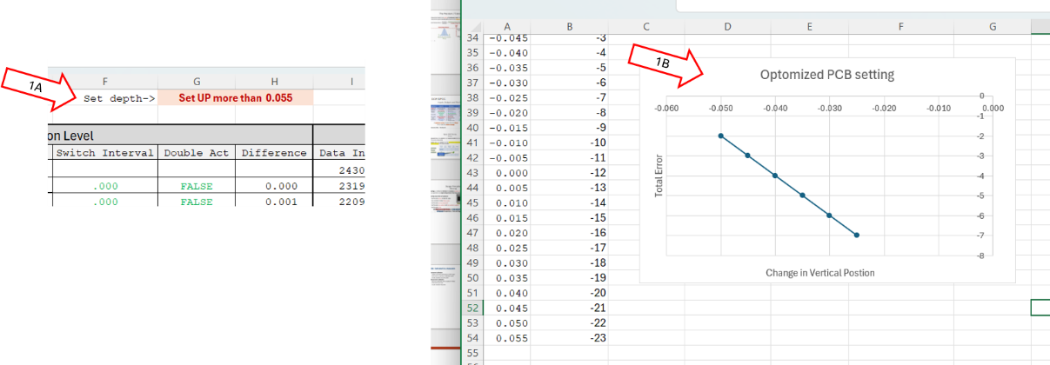
Report File Analysis Sheet Showing PCB set depth
- Start the MLOI Program and wait for the Level to STOP.
- On the Test Information dialog, set:
Test | Pre-Pot |  | Pre-Fill to | ON
- Verify the application is open and running and TEST State Out is in START mode.
- Verify Run Test is RUNNING and Green.
- Verify Test State out indicates Pre Fill or Pre Drain as appropriate.
- Verify the linear Level profile as shown in Pre-Lube chart below.
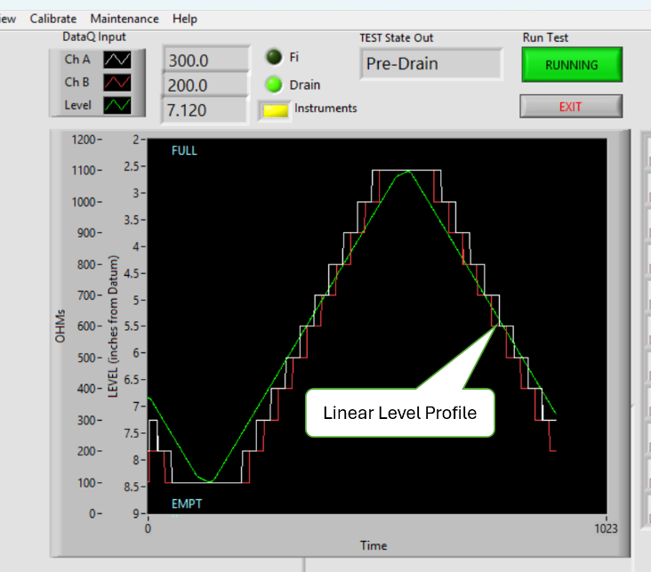
Pre-Lube Chart
- Wait until the prefill completes with the tank EMPTY.
- Verify the Chart shrinks to show the Level Controller
- Verify the Test State out is Manual
- Verify the Run Test button is grey and START
- Set Level SP to Full Tank, while the motor is running press the EXIT button.
- Verify the pump stops.
- Verify the app closes.
NOTE: If the pump continues to run after the app exits, then press the panel E-Stop button.

Tester __________________ Date ______________ PASS FAIL

NOTE: All the preceding tests of section 5.1.4 can be run with the instruments online, using an OLS sensor with the caveat the results will reflect the status of that OLS sensor.

Development HMI:

NOTE: In the Development environment, these HMI test in the user mode are identical to the user mode in the Production environment except as noted.

NOTE: These HMI tests of software requirements may be evaluated in either test (with instrumentation) or simulated (without instrumentation) methods. The following tests may be evaluated in SIM mode except as noted.

- Shall provide a means to manually control the Tank Level.
- Disconnect the instruments.
- Run MLOI program,
Test | Post-Pot |  | Pre-Fill to | ON
- Display the Motor Control
- Click on the Running button.
- Verify the chart becomes narrower and Motor Controls are displayed.
- Change Level SP, verify the Level PV drives to the Level SP value
- Repeat for several Level SP values.
- Restart MLOI program,
- Select Post-Pot, turn off Pre-Fill, Click OK
- Display the Motor Control
- Click on the Running button.
- Verify the chart becomes narrower and Motor Controls are displayed.
- Change Level SP, verify the Level PV drives to the Level SP value
- Repeat for several Level SP values.

- Set the Mode to Maintenance, Restart the MLOI program
Test | Post-Pot |  | Pre-Fill to | ON
Auto Start | OFF |  | JOG | ON
- Verify that the SP Slider has no control over PV
- Verify that the SP Slider and its digital output read approximately the same value over the slider range.
- Press the FILL Button
- Verify that the FILL button is ON (green) and the DRAIN button is OFF (gray)
- Verify the Speed becomes SLOW, and Level and PV values decrease towards FULL and the Green plot rises.
- Verify the Level value (above the plot) and the PV digital output read the same Level value.
- Verify that that PV slider and its digital output read approximately the same value over the slider range.
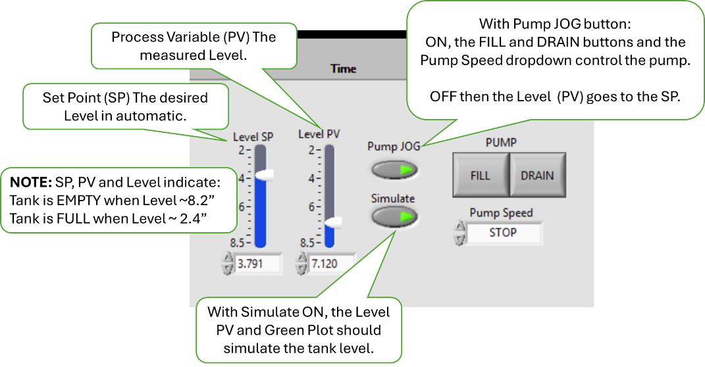
- In turn, set the Pump Speed to CREEP, SLOW, FAST.
- Verify that Level, PV and the green plot respond corresponding to the selected Speed. FAST is faster than SLOW which is faster than CREEP which is faster than STOP.
- Change the Pump Speed to Stop
- Verify the Level, PV and Plot stop changing.
- Verify that both FILL and DRAIN buttons are OFF (gray).
- Press the DRAIN button
- Verify that the FILL button is OFF (gray) and the DRAIN button is ON (green)
- Verify that PV slider and its digital output read approximately the same value over the slider range.
- Verify the Level value (above the plot) and the PV digital output read the same Level value.
- Verify that Level and PV values increases towards EMPTY and the Green plot falls.
- Change the Pump Speed to CREEP, SLOW, FAST.
- Verify that Level, PV and the green plot respond corresponding to the selected Speed. FAST is faster than SLOW which is faster than CREEP which is faster than STOP.
- Verify that both FILL and DRAIN buttons are OFF (gray).
- Alternate pushing FILL and DRAIN buttons
- Verify Speed goes to SLOW.
- Verify Speed can be changed in both FILL and DRAIN modes.
- Verify FILL and DRAIN can NOT be both ON (gray) at the same time.
- Set Pump JOG to OFF (gray). Set the SP slider to various Level Values.

- Verify the Level value, PV and Plot all drive toward the SP values and stop within 5% of the SP value.
- Ensure that the Laser and the Pump status lights are GREEN. Then Set the Simulate button to OFF (gray).
- Connect the instruments and USB hub, with SIM Mode OFF Repeat Steps 2 through 8
- Verify the actual tank performed the same as the simulated tank.

Tester __________________ Date ______________ PASS FAIL

- Shall display the current ChA and ChB measurement to 0.1Ω
- Shall display the level measurement to 0.001”
- Shall provide time-based plot of the resistance for both ChA and ChB, and tank Level.
- Verify Resistor and Level Measurement in SIM mode.
- Run MLOI. Start the MLOI Program, On the Test Information dialog, set:
Test | Post-Pot |  | Pre-Fill to | OFF
Replicate to | 0 |  | Auto Start to ON | ON
 |  |  | Start in Jog to | OFF
- Click OK, Simulate and Continue.
- Set Level SP to a value between 2.4 and 8.5.
- Verify that stair step plot and that ChA and ChB values represent the charted Resistor Values (White and Red Plot) to one decimal place.
- Verify the Level values represent the charted Level values (Green Plot) to three decimal places.

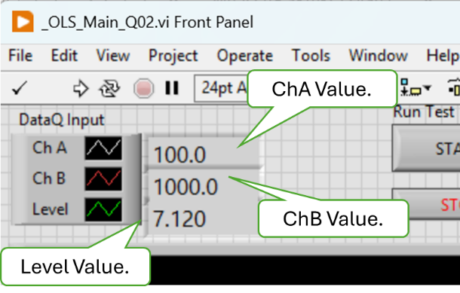

- Verify Resistor and Level Measurement in TEST mode. Connect the instruments and USB Hub.
- Run MLOI. On the Enter Test Information dialog, select Post-Pot, set the Pre-Fill to OFF, Auto Start option to OFF, Start in JOG to OFF and Replicates to 0. Click OK, Simulate and Continue.
- With the MLOI app running, install the 100Ω test resistor.
- Verify that ChA Value and the white plot on the chart indicates about 100.0
- Verify that ChB Value and the red plot on the chart indicates about 100.0
- Verify that the Level reading is to three (3) decimal places and is displayed as green plot on the chart.

- Install the 1KΩ test resistor.
- Verify that ChA Value and the white plot on the chart indicates about 1000.0
- Verify that ChB Value and the red plot on the chart indicates about 1000.0
- Verify that the Level reading is to three (3) decimal places and is displayed as green plot on the chart.

Tester __________________ Date ______________ PASS FAIL

- Shall display the Pass/Fail status and progress of the test.
- Run MLOI. Start the MLOI Program, On the Test Information dialog, set:
Test | Post-Pot |  | Pre-Fill to | OFF
Replicate to | 0 |  | Auto Start to ON | ON
 |  |  | Start in Jog to | OFF
- Click OK, Simulate and Continue.
- Verify the application is open and running and TEST State Out is in MANUAL mode.
- With the MLOI app running, Press the Run Test button to Running (green). Let the test progress.

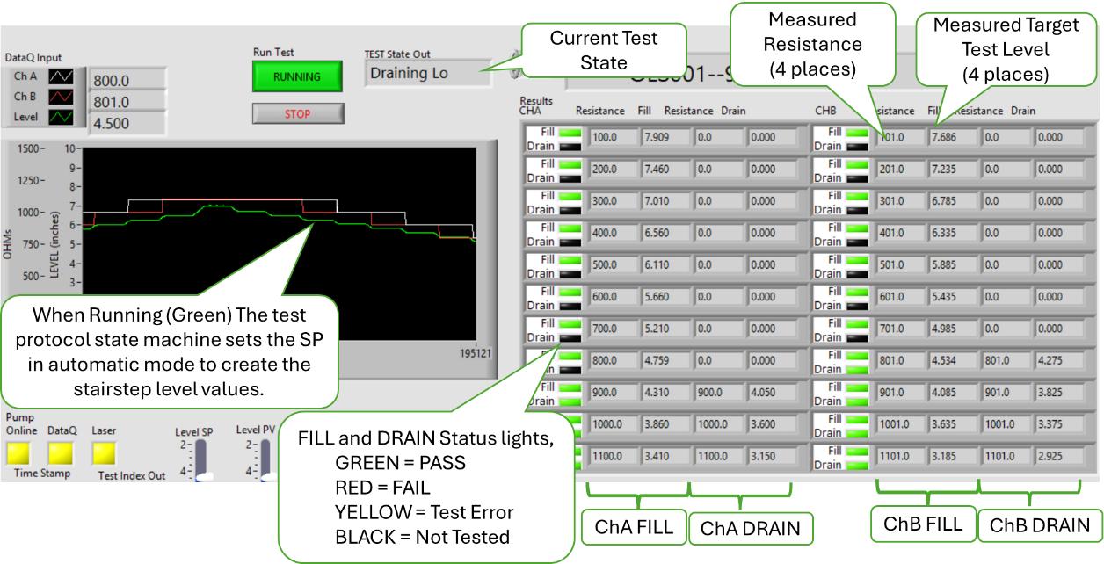

- Verify that Test State Out is sequencing through the test protocol.
- Verify the plots on the charts indicate the test protocol progress as stair step plots.
- Verify both the Fill and Drain status lights indicate test status as the test progresses.
- Verify the Resistor and Fill/Drain field are populated with the ChA, ChB and Level PV values as the test progresses.
- When the test is completed, (DONE state) at the prompt press SAVE button then exit the test.
- Verify that a report is generated and saved as an XL workbook and the app closes.

Tester __________________ Date ______________ PASS FAIL

Document management
- The test plan-> Configuration File shall be an XL workbook named to be traceable the test protocol implemented.
- The test plan-> Configuration File shall be version controlled in the Test repository per AAP QUAM.

- The test plan-> Configuration File shall be capable of containing multiple templates to accommodate recording multiple test points or variations of test protocol.

- On the AAP network, navigate to the Configuration document in the form of an XL workbook (Config File) located in AAP Controlled Documents Vault located at M:\<Path to Controlled Documents Vault>.
- Verify that the Config File was approved by Engineering and Quality Assurance.
- Verify that the current version of the Config File is saved in the AAP Controlled Documents Vault located at M:\<Path to Controlled Documents Vault>.
- Verify the Config File name contains the common part number of the product associated with this test protocol configuration named to include the product ID.
- Notice there are both a CSV and an XLSM file named by product ID for each Configuration. The CSV file is read and used by the MLOI program. The XLSM has should be used to modify the configuration parameters because it has explanatory tool tips on the field names.
- If necessary, create a second test file by creating a copy of the existing Config File and rename it to CFG_1234_Dummy.xlsm
- Open Test Config File CFG_1234_Dummy.xlsm and change Test Type (Cell B4) to TEST001.
- Save and close Config File CFG_1234_Dummy.xlsm, click
- Verify that a CSV file named CFG_1234_Dummy.csv is created in the $ConfigFile folder.
Initialize the path to the folder containing the Configuration Files
- Set Mode to User Run MLOI. Start the MLOI Program, On the Test Information dialog, set:
Test | Post-Pot |  | Pre-Fill to | OFF
- Click OK, Simulate and Continue.
- Click on Menu>Maintenance>Initialize
- Enter access code 1492, Click OK
- Click on Test Configuration to open the dropdown list of files.

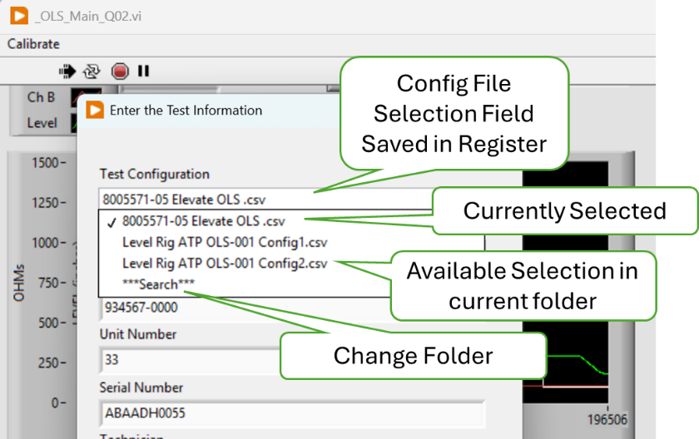
Configuration File Folder Selection

- Click on “**Search**” in the dropdown list to navigate to a the folder from step 1 folder, select CFG_<ProductID>.csv ConfigFile.
- Press OK.
- Click Restart
- Set Mode to User Run MLOI. Start the MLOI Program, On the Test Information dialog, set:
Test | Post-Pot |  | Pre-Fill to | OFF
- On the Test Configuration File dropdown. Select CFG_1234_Dummy.csv,
- Click OK, Simulate and Continue.
- Verity the Test Type parameter (TEST001) is displayed as prefix to Test Name

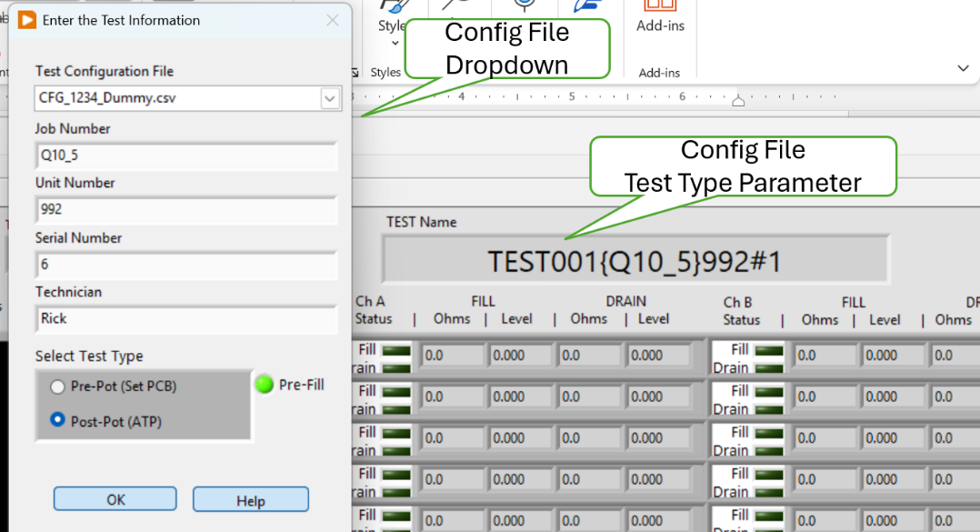
Selecting a Configuration File
- Exit MLOI,
- Set Mode to User. Run MLOI. Start the MLOI Program, On the Test Information dialog, set:
Test | Post-Pot |  | Pre-Fill to | OFF
- On the Test Configuration File dropdown. Select CFG_1234_Dummy.csv,
- Select CFG_8005571-05 Elevate OLS.csv
- Click OK, Simulate and Continue.
- Verity the Test Type parameter (OLS001) is displayed as prefix to Test Name
- Exit MLOI

Tester __________________ Date ______________ PASS FAIL

Generate DUT Test Report
- The Test results and the Product information for each test shall be saved in one XL workbook at the option of the operator.

- The ATP Test Report shall be on one sheet labeled “ATP Report” as specified in the Report Template supplied by Engineering.
- On the AAP network, navigate to the Report Template document in the form of an XL workbook (Config File) located in AAP Controlled Documents Vault located at M:\<Path to Controlled Documents Vault>.
- Verify that the RPT_Template_<Rev Number>.xlsx was approved by Engineering and Quality Assurance.
- Verify that the current version of the RPT_Template_<Rev Number>.xlsx File is saved in the AAP Controlled Documents Vault located at M:\<Path to Configuration Files folder>\$ConfigFile folder.
- Verify a folder to receive the Report Files has been created at M:\<Path to Report Filest>\$ReportFiles folder.

Initialize the path to the folder containing the Report Files
- Set Mode to User Run MLOI. Start the MLOI Program, On the Test Information dialog, set:
Test | Post-Pot |  | Pre-Fill to | OFF
- Click OK, Simulate and Continue.
- Click on Menu>Maintenance>Initialize
- Enter access code 1492, Click OK
- Click on Test Report Save Folder to open the dropdown list of files.

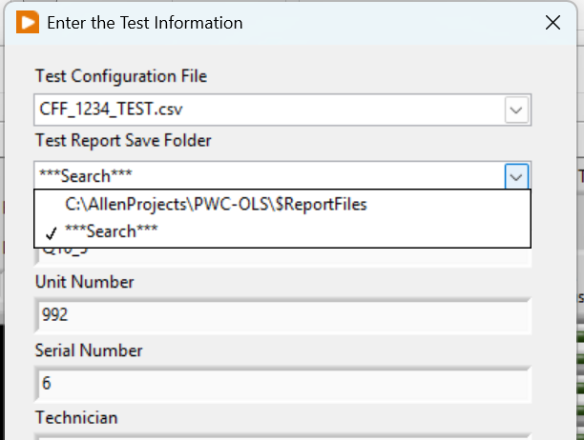
Test Report Save Folder Selection

- Click on “**Search**” in the dropdown list to navigate to the $ReportFiles folder from step 1 folder.
- Press Select Folder, Click OK.
- Click Restart

- Set Mode to User Run MLOI. Start the MLOI Program, On the Test Information dialog, set:
Configuration File | CFG_1234_Dummy |  | Job Number | QTP
Unit Number | 992 |  | Serial Number | 9
Technician | Tester
Test | Post-Pot |  | Pre-Fill to | OFF
- On the Test Configuration File dropdown. Select CFG_1234_Dummy.csv,
- Click OK, Simulate and Continue.
- On the Main Menu click each of the View options.
- Verify that the Files & Paths indicated the selected Files and Paths.
- Verify the Test Info indicates the entered Test Information
- Verify the Calibration Parametes indicated the values saved in the CFG_1234_Dummy.xlsm.
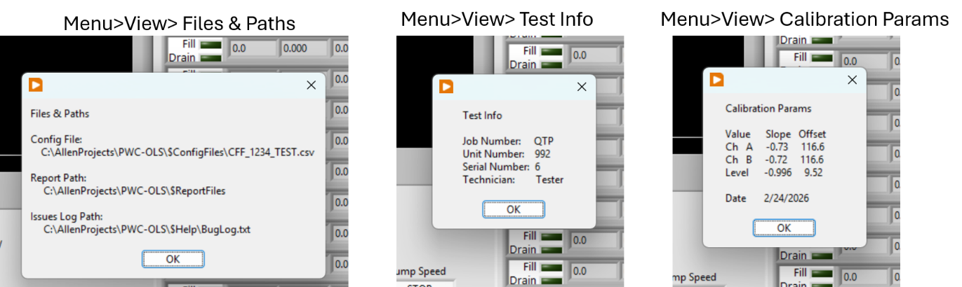
Menu View Expected Response
- When the simulated test competes, if presented, press SAVE report.
- Verify the Report file named RPT_TEST001{QTP}992#1%<TimeStamp_yymmddhhmm>.xlsx is located in folder <path from step 1>\$ReportFiles\QTP

Tester __________________ Date ______________ PASS FAIL

- Shall produce a PASS FAIL report based on ATP Test criteria.
- The ATP Report shall contain the pertinent Test Information.
- Open the report file generated in test case 41 step 7 above. Select the worksheet named ATP Report
- Verify the Report Title is “8005571.05 Elevate Oil Level Sensor”
- Verify the Test Information:
Job Number | QTP |  | Unit Number* | 992#1
S/N | 6 |  | Technician | Tester
Technician | Tester |  | Date | mm/dd/yyyy
File | RPT_TEST001{QTP}992#1%<yyyymmddhhmm>.xlsx
* The number following the pound sign indicated the test sequence of possibly replicated tests. In this case this report is for the first time this unit test was run.
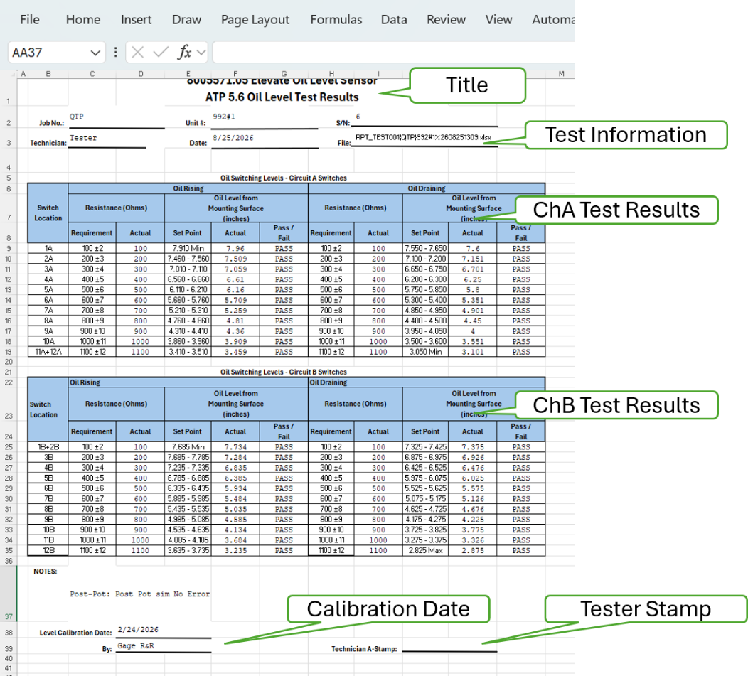
ATP Report
- Verify the Version number is correct.
- Verify ChA Test Results and Ch B Test results as PASS
- Verify that the ChA and Ch B Actual Level is (SP_{HI} + SP_{LO})/2
- Verify the Calibration Date indicates the Calibration Parameter values.

Tester __________________ Date ______________ PASS FAIL

- The time in 50ms intervals, ChA and ChB resistance in ohms and Level in inches shall be recorded and plotted on a sheet labeled “Raw Data.”
- Open the report file generated in test case 41 step 7 above. Select the worksheet named Raw Data
- Verify the Version number is correct.
- Verify the Report file name
- Verify the Calibration Parameters
- Verify the Raw Data: Time, ChA Ohms, ChB Ohms, Laser Raw, Leve PV
- Verify the Fill = 1.00 and Drain = 0.00 indicator
- Verify the Data plot
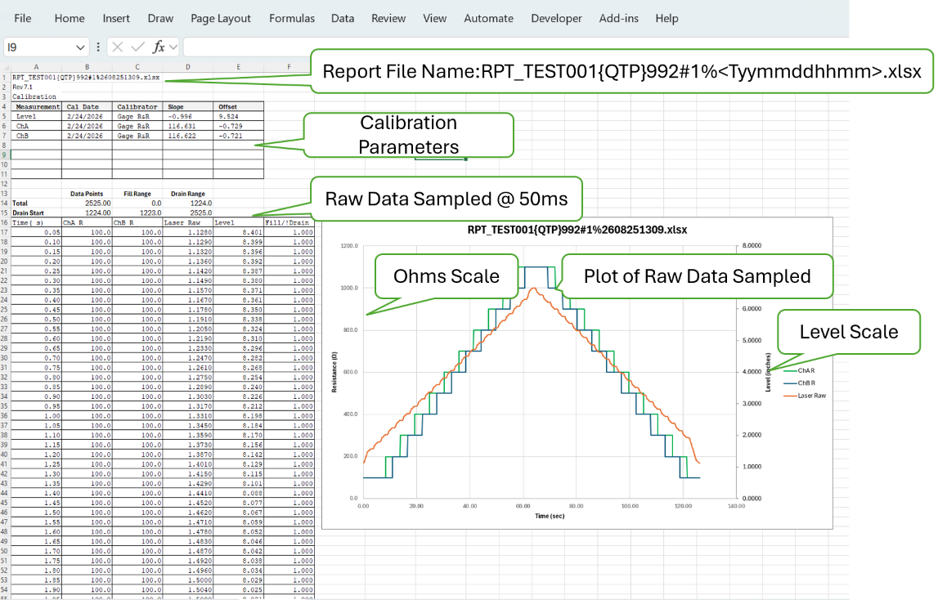
Report Raw Data Worksheet

Tester __________________ Date ______________ PASS FAIL

- The third sheet shall be labeled “Analysis” and include the actual level at which the Switch Point occurred (L_{SWP} refer to figure 2).

- The sheet labeled “Analysis” shall include identification of “double actuations” (definition TBD) and slow “rise time” (definition TBD).
73) The values on the Analysis sheet may be calculated post-test execution.

- Shall have a means to assist the operator in setting the sensor PCB depth.

NOTE: The values on the Analysis sheet may be calculated post-test execution.

- Open the report file generated in test case 41 step 7 above. Select the worksheet named Analysis
- Verify the table beginning in col Q matched the values provided in the reference DUT ATP Reference document.
- Scroll to the left and verify the Version number
- Verify the ChA and ChB results Fill Difference is in range of 0.000 to 0.001
- Verify the ChA and ChB results Drain Difference is in range of 0.000 to -0.001
- Verify that all Double Actuations are FALSE
- Verify Optimized PCB Setting is 0.000
- Verify the Optimized PCB Setting plot is displayed as shown.
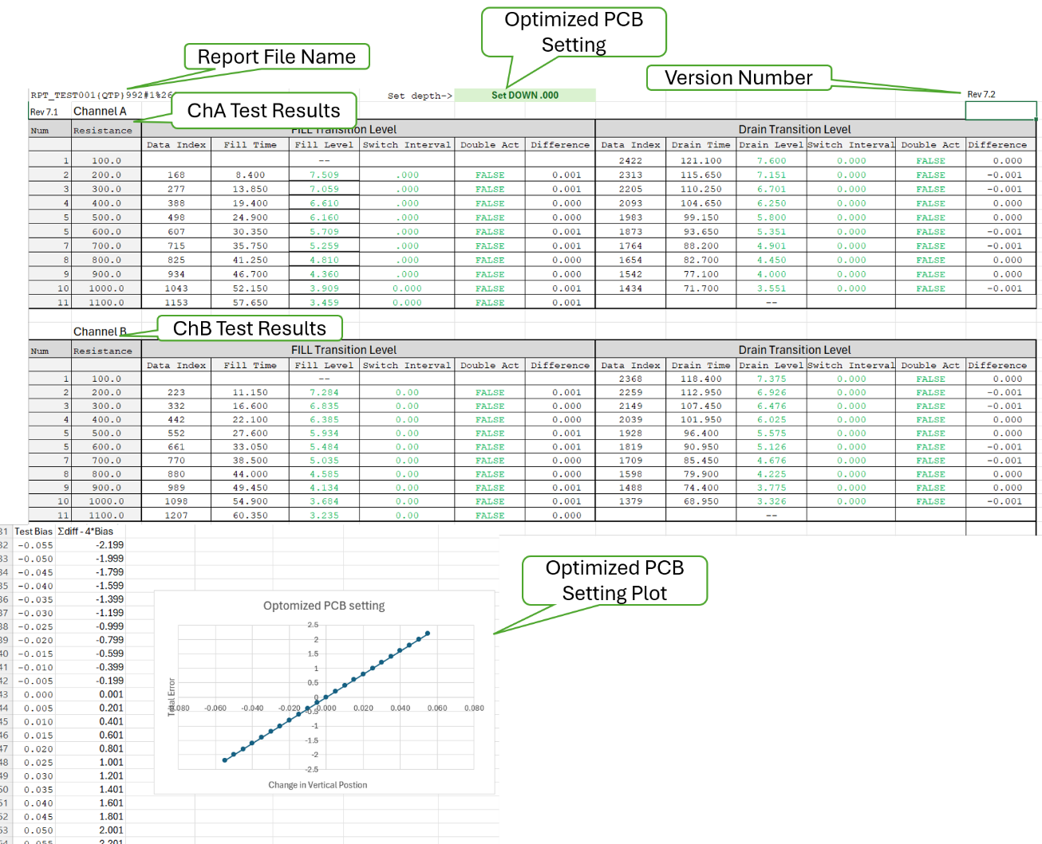

Tester __________________ Date ______________ PASS FAIL

Troubleshooting Aids
- There shall be a means for manually setting the tank level.

- Each instrument (DataQ, Keyence) shall provide a health indicator.

- There shall be a simulated mode that provides simulated instrument input and Level response to be used with debugging.
NOTE, In the early development stage, I wrote an algorithm to read and AEPS data as an alternative input source, is this feature something we wish to keep in the final product?

- Shall have a means to evaluate the Pass/Fail criteria
- Set Mode to Maintenance. Run MLOI. Start the MLOI Program, On the Test Information dialog, set:
Test | Post-Pot |  | Pre-Fill to | OFF
Replicate to | 0 |  | Auto Start to ON | ON
 |  |  | Start in Jog to | OFF
- Click OK, Simulate and Continue.
- Check normal operation with no errors
- In the Debug Test box, set Ch A Bad Sw Zone and Ch B Bad Sw Zone switched to OFF (down)
- Click the START button
- Verify that the test program completes with not errors
- Verify that both ChA And ChB plots show nominal resistor values in increments of 100Ω
- Check operation with known ChA error present.
- In the Debug Test box, set Ch A Bad Sw Zone switch ON (up)
- Set A EnRate (random probability of selectin a 40Ω error in ChA reading) to 100.
- Set Ch A Ohms to 200
- Click the START button
- Verity the plot indicates ChA error at 200Ω
- Verify the chart records an ChA 200Ω as 160 Ω
- Verify the indicators at ChA 200Ω are red.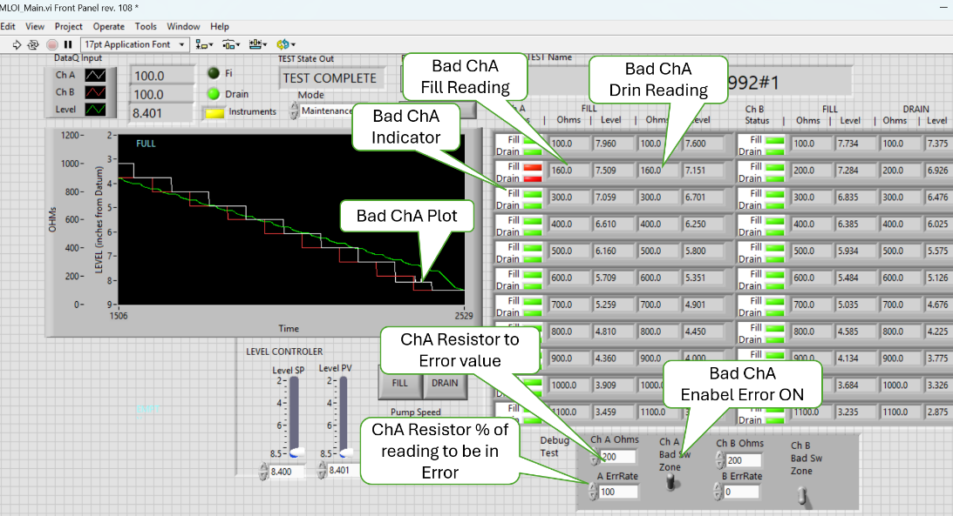
ChA with 200Ω in error with value of 160Ω
- Set ChA A ErrRate 20%
- Restart the program Press START
- When the level value is less then 6.8” Set ChA A ErrRate 5%
- Verity the plot indicates ChA error at 200Ω
- Verify the chart records an ChA 200Ω as 160 Ω
- Verify the indicators at ChA 200Ω are red.
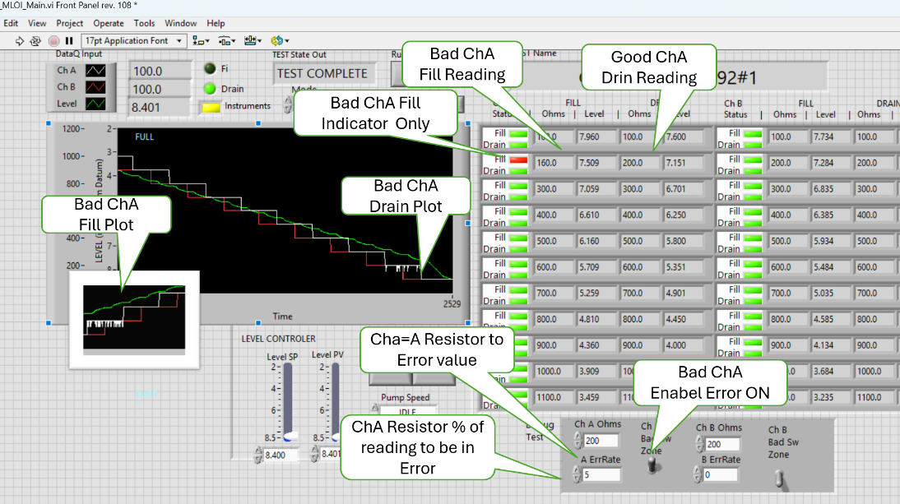
ChA with ErrRate set to 20% Fill and 5% Drain

NOTE: Because the ChA A ErrRate less than 100% it is more likely that the error will not be recorded or indicated as this value decreases, as shown below. This issue is relegated to the formula on the Analysis sheet to the corresponding Report Workbook.

- Set Mode to Maintenance. Run MLOI. Start the MLOI Program, On the Test Information dialog, set:
Test | Post-Pot |  | Pre-Fill to | OFF
Replicate to | 0 |  | Auto Start to ON | OFF
Unit Number | 001 |  | Start in Jog to | OFF
- Click OK, Simulate and Continue.

- Generate known errors for evaluation in the Report File.
- In the Debug Test box, set Ch A Bad Sw Zone switch ON (up)
set Ch A Bad Sw Zone switch | ON (up) |  | set Ch A Bad Sw Zone switch | ON (up)
ChA Ohms | 200 |  | ChB Ohms | 500
A ErrRate | 100 |  | B ErrRate | 5
- Click START, verify the test runs.
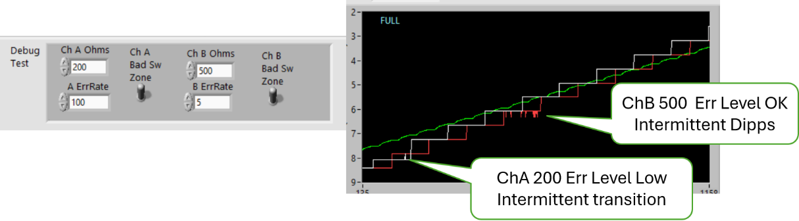
Error Generation
- At the end of the test click SAVE to generate the report.
- Open Assess the report file RPT_TEST001{QTP}001#1%yyyymmddhhmm.xlsx
- On the ATP Report sheet. Verify ChA 200 ohms indicated FAIL ChB MAY indicate FAIL on 500 ohms but not likely because of low error rate.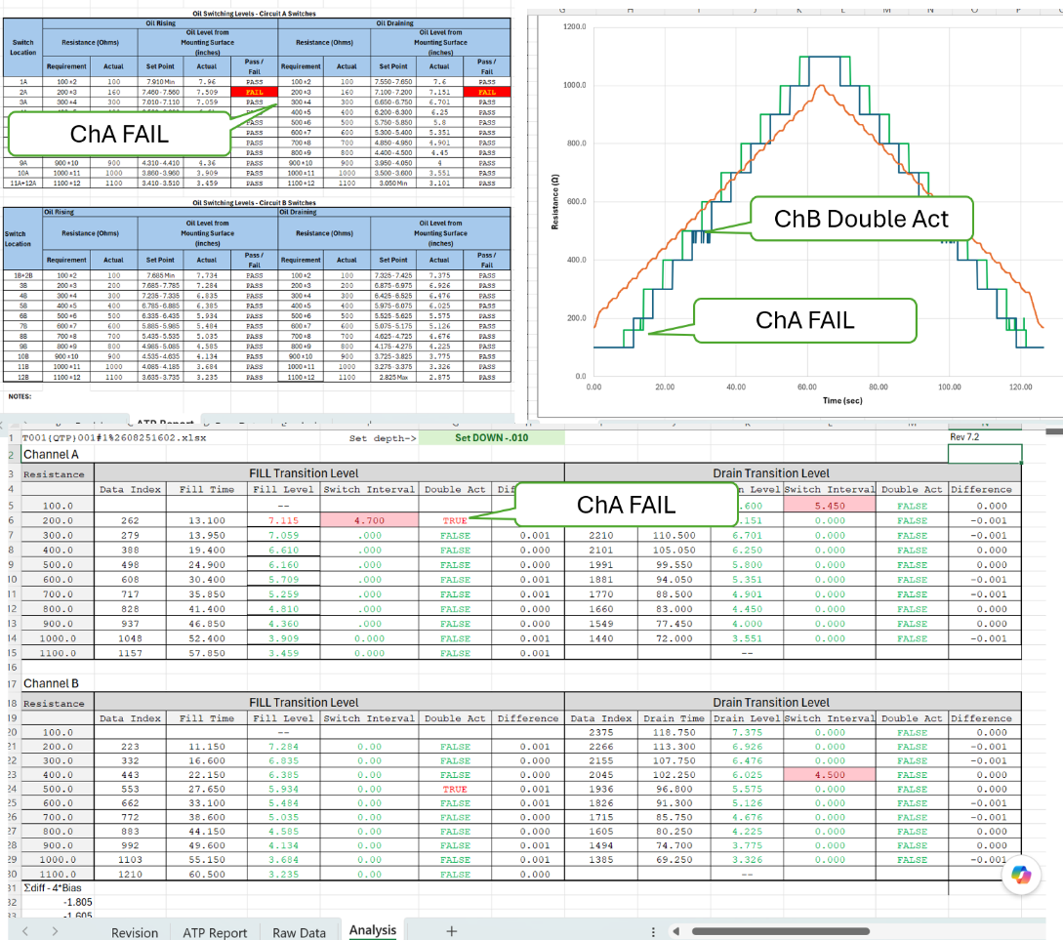
Report File Worksheets
- On the Raw Data Sheet, verify that the ChA Fail at 200 ohms is evident on both the Fill and Drain portions of the curve.
- On the Raw Data Sheet, verify that the ChB Double Actuation at 500 ohms is evident on both the Fill and Drain portions of the curve.
- On the Analysis Sheet, verify that the ChA Fail at 200 ohms indicates a Fill Level fail, a Switch Interval and Double Act error in red.
- On the Analysis Sheet, verify that the ChB Double Actuation at 500 ohms is indicated in red font.
- Repeat this test with several different fault conditions.

Tester __________________ Date ______________ PASS FAIL

  - Non - Functional Requirements Test Procedures
The following are performance evaluations of the MLOI system.

Annual Level Calibration Type 1 Gage and Capability Study

31) There shall be a means to perform a 5-point linear calibration of the Level Sensor.
The purpose of Annual Level Calibration is to determine the Slope and Offset calibration coefficients that scale the laser reading to correspond to the gage level measurement as shown in Type 1 Gage Study. The Level calibration procedure selects levels at the five quartile boundaries with +/- 0.100” random offset that the calibrator sets using the digital height gage, then the program records laser reading. A linear regression is performed on these 5 points to determine the calibration coefficients which along with the raw data are recorded in the $Calibration.xlsx workbook.

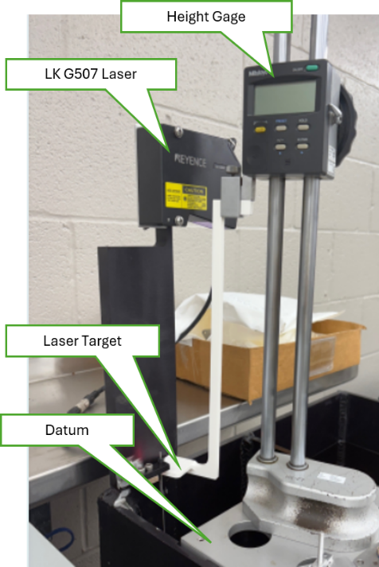
Procedure
- Tare (zero) the height gage (± 0.001”) to Datum
- Start a 5-point level calibration $MLOI_LevelCalibration.vi
- Set the target to the exact level for each test point.
- Press Save to record the laser reading at that point.
- Repeat trial run for each of 5 level Test Points,
- Record slope and intercept for this calibration
- Repeat calibration 5 times.
 | Coefficients | Lower 95% | Upper 95%
Intercept | 9.190 | 9.188 | 9.192
Laser | -0.997 | -0.999 | -0.995
- Calculate Confidence Limits for Slope and Intercept for 5 calibrations and save the coefficients in the Configuration File.

Level Capability
Tolerance = 0.100” (± 0.050”)
Study Variation (SV) = 6σ
SV = 6 * 0.0017= 0.0102
C_{g} = .2 * Tolerance / SV
C_{g} = 0.02/ 0.0102
C_{g} = 1.96 Greater than 1.33
so must accept Level SANS FLOAT
IS CAPABLE

Tester __________________ Date ______________ PASS FAIL
Daily Level Zero Correction Check

Daily (first time run each day) Zero check uses a gage block to determine the offset correction that is applied to the calibration. The laser span and linearity are considered stable and only require an annual calibration check. However the addition of the float introduces the potential for some variance in the offset. For this reason, it is deemed necessary to check the level zero prior to the use of MLOI each day.

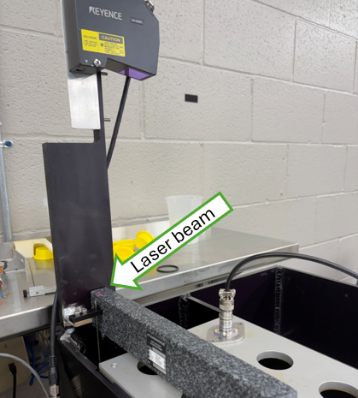
Procedure

    - Upon starting MLOI for the first time of the day, the user is prompted to Zero the Laser Measurement once the laser is online.

    - The user is prompted to place the 2.000” gage block on the datum reference plane.

    - Ensure that the gage block is flat across the top plate and the red laser beam is shining on the gage block.

    - Normally the operator would Save the new Level Zero at this point or contact Test Engineer if the New and Old Zero’s are significantly different.

Tester __________________ Date ______________ PASS FAIL

Resistance Calibration Repeatability & Accuracy

30) There shall be a means to perform a 2-point linear calibration on each AI input.
The purpose of Resistor Calibration is to determine the Slope and Offset calibration coefficients that scale the DataQ reading, 14.7ma current source, and buffer circuit to present the measured resistance at the nominal reference current. The Resistance calibration procedure uses two reference resistors with known values of 100.0Ω and 1000.0. A linear regression is performed on these two points to determine the calibration coefficients which are recorded in the $Calibration.xlsx

Procedure
- Start a 2-point resistor calibration $MLOI_ResistorCalibration.vi
- Follow the prompts to measure the resistance references if necessary
- Insert the 100Ω Reference as the front panel DUT. Click OK to record the Resistance.
- Insert the 1KΩ Reference as the front panel DUT. Click OK to record the Resistance.
- The data and the calibration coefficients are recorded on Elevate Resistance sheet of $Calibration workbook. Record the coefficients in the $ConfigFile.

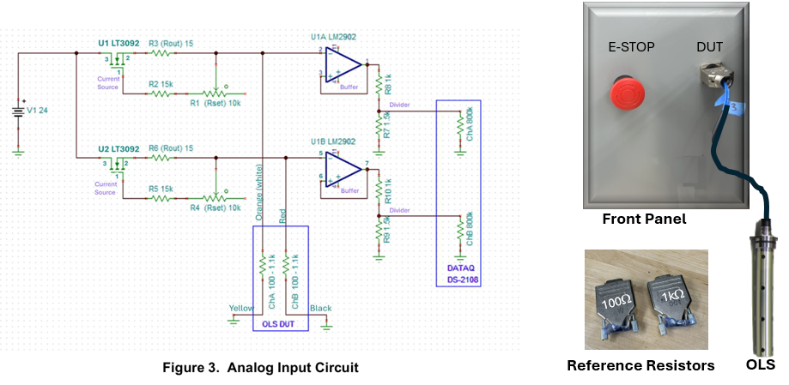
RESULTS:
Channel | Slope | Intercept
Ch A | 116.631 | -0.729
Ch B | 116.622 | -0.721

Double check this table
Resistor Capability
Tolerance = 2.0Ω (± 1.0Ω)
Study Variation (SV) = 6σ
SV = 6 * 0.0017= 0.0102
C_{g} = .2 * Tolerance / SV
C_{g} = 2,0/ 0.78
C_{g} = 2.56 Greater than 1.33
so must accept Level SANS FLOAT
IS CAPABLE

Measurement Gage R & R
Stability and Drift

- Hardware Installation

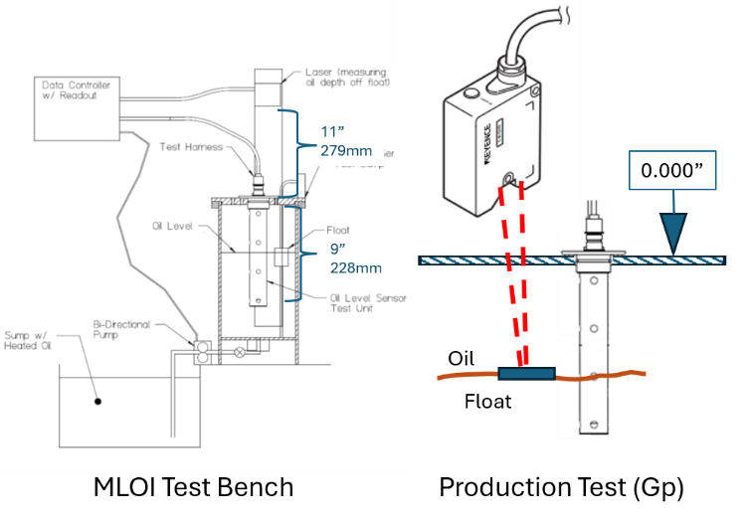
Diagram of the MLOI Test Hardware

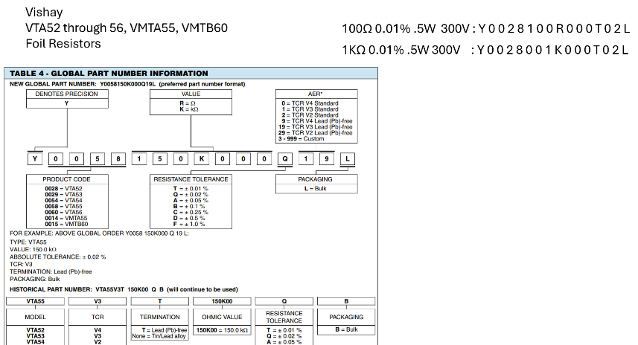
Reference Resistors for DataQ Calibration

- Instrument Initialization

Keyence LK-G500
Download and install LK-Navigator from keyence.com
Download the LK-G3000 Series LabVIEW measuring instrument drivers and copy the entire folder containing "Keyence LK-G3000" to the instr.lib folder of LabVIEW. Location of the instr.lib folder Example: C:¥Program Files(x86)¥National Instruments¥LabVIEW 2012¥instr.lib
- Open the driver path vi in the LK-G3000 LabVIEW driver folder
..\LabVIEW_InstrDriver_forLK-G3000_ver1_0_1_0\LabVIEW_InstrDriver_forLK-G3000_ver1_0_1_0\32bit\Keyence LK-G3000\Private\vi\Get DLL Path.vi
- Then set the path to LKIF drivers as shown below:

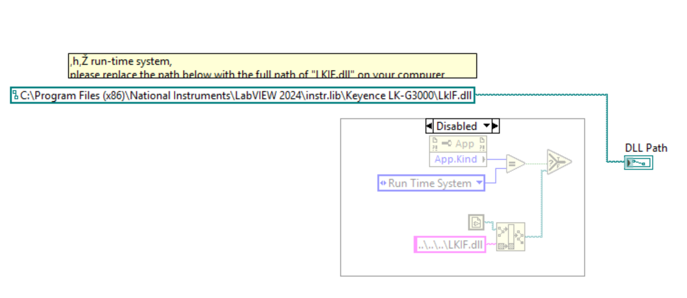
- Copy the entire “KeyenceLK-G3000” folder to
C:\Program Files (x86)\National Instruments\LabVIEW 2024\instr.lib\
- Open LabVIEW, from the main menu>tools>Advance>Mass Compile, navigate to
C:\Program Files (x86)\National Instruments\LabVIEW 2024\instr.lib\Keyence LK-G3000
- Perform a Mass Compile on the “Current Folder”

Optionally run the following Connection Tests (..\PWC-OLS\Instrument Info\CNXN_Tests)
- CNXN_LaserCnxn.vi

Pololu 18V7 Motor Controller
The Pololu 18V7 Simple Motor Controller is a versatile, general-purpose motor controller for brushed DC motor having a wide operating range of up to 5.5–40V and the ability to deliver 7A.

- Download and install the Simple Motor Controller Windows Drivers and Software [https://www.pololu.com/file/0J408/smc-windows-121204.zip] (5MB zip) on the MLOI target workstation.
- After the installation is finished, your start menu should have a shortcut to the Simple Motor Control Center (in the Pololu folder). This is a Windows application that allows you to configure, control, and get real-time feedback from the Simple Motor Controller.
- After installing the drivers and plugging the Simple Motor Controller in via USB, if you go to your computer’s Device Manager, you should see two entries for the Simple Motor Controller that look like what is shown below:

- Optionally run the following Connection Tests (..\PWC-OLS\Instrument Info\CNXN_Tests)
- CNXN_Polulu_18V7MC.vi

DataQ DI-2008
The DATAQ DI-2008 is a USB thermocouple and voltage data acquisition system with 8 isolated analog channels, 7 digital I/O ports, 16-bit resolution, and built-in sensor excitation.

The native communication mode of the DI-2108 is LibUSB but it can be switched to the USB CDC (Communication Device Class). CDC mode allows the USB port of DI-2108 devices to appear like a traditional RS-232 port, which is common across most operating systems and development languages. Please note: LibUSB communication is required for WinDaq Acquisition software and programming with our .NET SDK.

MLOI Uses the CDC mode. To switch your device to/from LibUSB/CDC modes:
  - Connect the device to your PC via the USB port.
  - Apply power to the device.
  - When mode LED stops blinking white and is in Idle mode, push and hold the Control button. This must be completed within five seconds after the device is in Idle mode.
  - When the mode LED turns red, release the Control button.
  - The Mode LED will flash white then indicate Idle in either LibUSB or CDC mode:
    - CDC mode: Blinking Yellow (MLOI Uses this mode)
    - Lib USB mode: Blinking Green

Device Manager shows DataQ connected to COM4 for example.
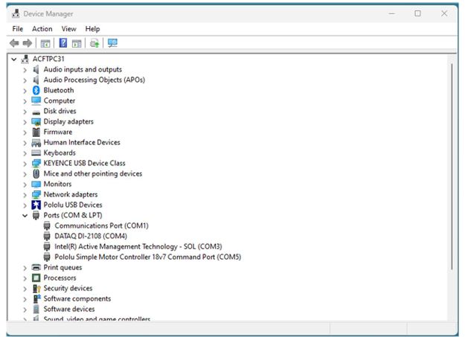
Device Manager Showing DataQ Connection

Optionally run the following Connection Tests (..\PWC-OLS\Instrument Info\CNXN_Tests)
      - CNXN_DataQ_GetID.vi to check the basic connection
      - CNXN_DataQ_protocol_2ch.vi to check the basic 2 channel analog function.
      - CNXN_DataQ_Digital_IO.vi to check the basic digital IO function.

- LabVIEW Application Installation

The LabVIEW application is run in a LabVIEW Runtime environment that must be loaded on the target workstation. And each instrument driver must be loaded per Appendix II. The LabVIEW app is version controlled in the Allen Aircraft GitHub account and should be downloaded from there.
- Have the IT department load the LabVIEW Runtime on the target workstation.
- Contact AAP IT department for GitHub login credentials.
- Open an internet browser and navigate to https://github.com/AllenAircraft/PWC-OLS/tree/main.
- On the Code page, from the top left button, select the code revision to be evaluated. Note that the Main branch is always the latest release
.
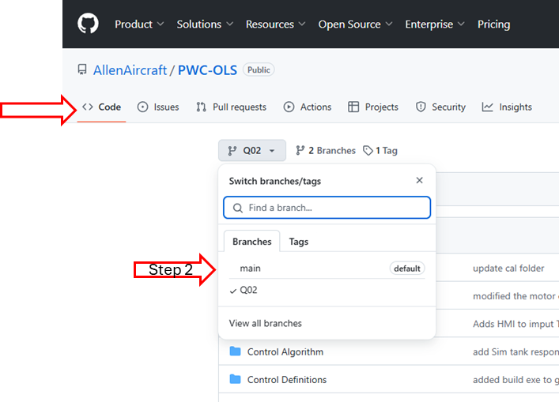

NOTE: The build folder containing MLOI_Elevate executable can be loaded as a stand-alone from the ZIP file (Step 5) or with the Development system (Step 6).
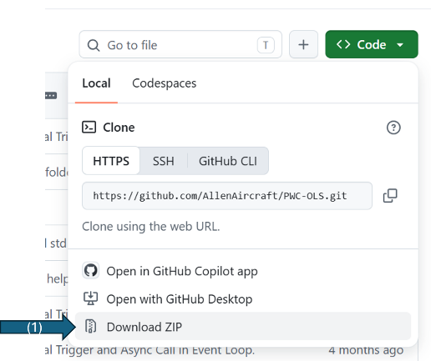
- To load only the executable files:
- Click the Code button, then select Download ZIP on the dropdown.
- Open the downloaded ZIP file and navigate the builds Folder.
- Extract the Build folder to the Target System.
- On the Target system navigate to ..\builds\MLOI_Elevate
- Create/Copy the $ConfigFile and $ReportFiles to the target system as necessary.
- To run the MLOI App, click MLOI_Elevate.exe
- To Copy the Development program to your development system:
- Navigate to a folder that will contain the working development project folder:
- Right click to open the popup and select Open in Terminal
- On the Github page, click on green Code button and select and copy (^C) https://github.com/AllenAircraft/PWC-OLS.git Cloning using the web URL.
- At the prompt in the Terminal type:
>git clone https://github.com/AllenAircraft/PWC-OLS.git
- Verify that MLOI development project folder is extracted to “PWC-OLS” on your development system.
- Open the new PWC-OLS folder on the target system and click on _MLOI_Main.vi to run the development version of the program.
- To run the Production Application, it is convenient to make a shortcut to ..\MLOI-Elevate\_MLOI_Main.exe and place that shortcut on the target desktop.
NOTE: The path to the Configuration File is saved on the Target system registry that must be initialized the first time MLOI is run or if the Configuration file is moved.

